MT+ Beneficiary Guide

Introduction 2
How to get access 3
Login 4
Automatic notifications 8
Menu and Navigation 9
List functionalities 12
Project Details 18
How to manage organisations 20
How to manage contacts 23
How to manage mobilities for KA1 and KA3 projects 29
How to manage activities for KA2 projects 34
How to complete and submit the beneficiary report 86

Introduction

What is the Mobility Tool+?
Mobility Tool+ is an Information System that allows Erasmus+ Beneficiary Organisations to access and manage their project's information, request individual participants' reports and submit final reports to their National Agencies. Erasmus+ National Agencies also use Mobility Tool+ to monitor and validate the projects information entered by Beneficiary Organisations at any time from anywhere.
Mobility Tool+ is designed, developed and maintained by the European Commission being used by Erasmus+ Beneficiary Organisations and National Agencies involved in decentralised projects.

What are KA1 and KA3 mobilities?
Each Erasmus+ key action is divided into different action types depending on the intended programmes objectives and target groups. Activity types therein further divide such action types into homogeneous groups of participants encoded as mobilities within Mobility Tool. Mobilities represent the sending of a particular individual from an origin country to a destination country typically within the set of Erasmus+ programme countries. Depending on the activity type concerned each participant in an Erasmus+ mobility is entitled to receive funds for travel, individual support, special needs, exceptional costs, etc. Mobility tool allows Beneficiary Organisations to manage all this information in a coherent and meaningful manner.

What about KA2 Strategic Partnerships?
Strategic partnerships' projects are also supported by Mobility Tool. Although not managing pure mobilities such projects need to be managed in terms of the outcomes and results they produce especially for those projects mostly concerned with development of innovation. Therefore Mobility Tool provides all needed functionality to create and manage a KA2 project allocation of funds for project management and implementation, transnational project meetings, intellectual outputs and associated multiplier events and individuals participating in learning, teaching and training activities, the latter mostly relevant for projects targeting exchanges of practices. The filling in and submission of final report by Beneficiary Organisations and subsequent validation by National Agencies is also available for KA2.

What are the different roles involved?
The management of the project and its contents is the responsibility of the Beneficiary Organisation users. Contacts defined in the electronic application form as contact persons and legal representatives for the applicant/beneficiary organisation will automatically have access to their corresponding projects in Mobility Tool+ This happens when the project's data is submitted from EPlusLink. National Agency users can also have access to Mobility Tool+ for monitoring and validation purposes.

How to get access
- How to get access to the mobility tool
  - Contact person from the beneficiary or coordinating organisation
  - Incorrect email address for contact person
  - National Agency User

How to get access to the mobility tool

Contact person from the beneficiary or coordinating organisation
Those persons who are indicated as the project contract person of the beneficiary or coordinating organisation in the National Agencies project management system EPlusLink will automatically be given access to MT+. This is usually the same details as entered in the application form, unless changed during the selection process. The email address associated with this contact person will receive the notification from the system once the project is created in the Mobility Tool. This contact person will be able to create new contacts with or without access to edit the project details in MT+.

Incorrect email address for contact person
If the incorrect email address is used for the project contact person, the National Agency should change the email address in their project management system EPlusLink and resend the data to MT+.

National Agency User
Contact your local MT+ National Agency Administrator (NA Admin) to gain access. If there is no NA Admin please create an issue in NAUAM to nominate a user as a MT+ National Agency Administrator.

Login
This page explains how to log in to MT+ using ECAS. An email notification will be sent to the project contact on creation of the project in the mobility tool.
- Select the "External" domain.
- Log In.
- Password lost?
- Create a new ECAS account.
- Help (Frequently asked questions).

Select the "External" domain.
The correct domain must be chosen before logging in. The correct domain for those working in the National Agency or those indicated as the project contact of the beneficiary or coordinating organisation must choose the domain External. To change the domain as External, click the CHANGE IT button.
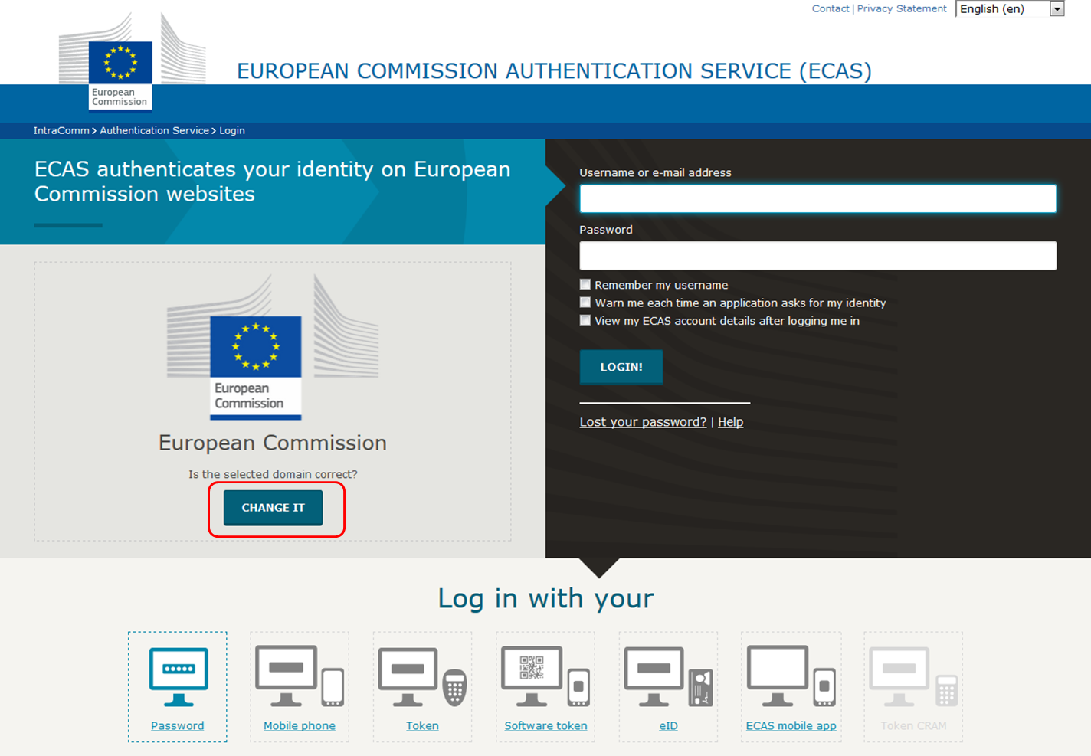

A list of several options will appear. Select the External domain.
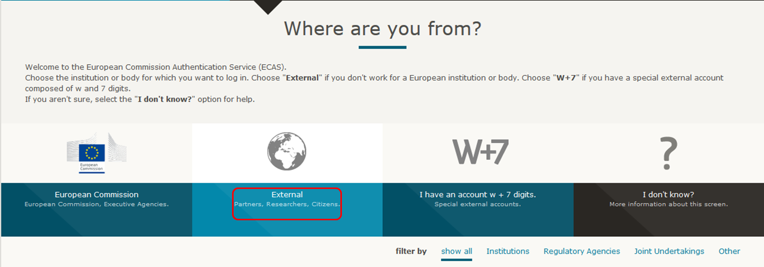

Log In.
Enter your ECAS Username or your e-mail address and your ECAS Password. This must be the same e-mail address as used by the e-mail notification informing you of your access. If you do not use the same e-mail address, you will not gain access to the project information.
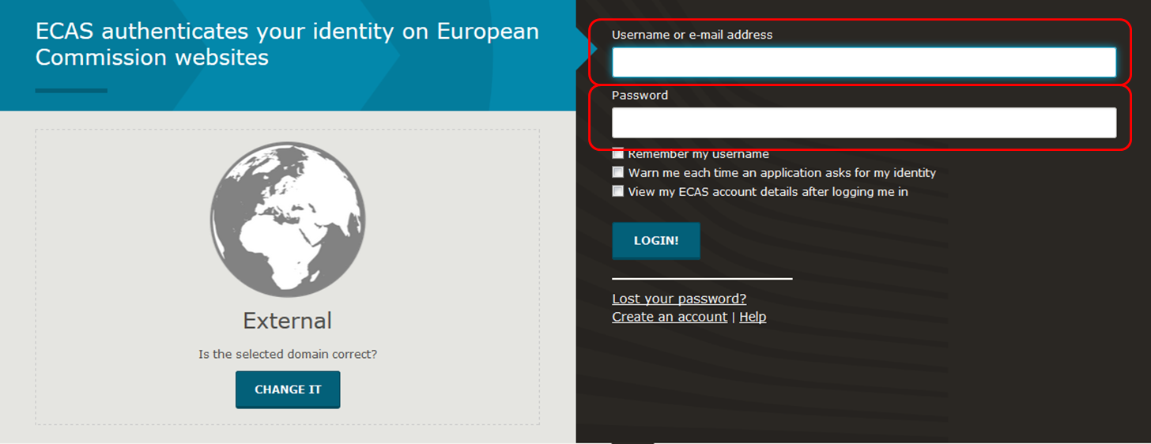

Once you entered your ECAS Username and Password, click the LOGIN! button.
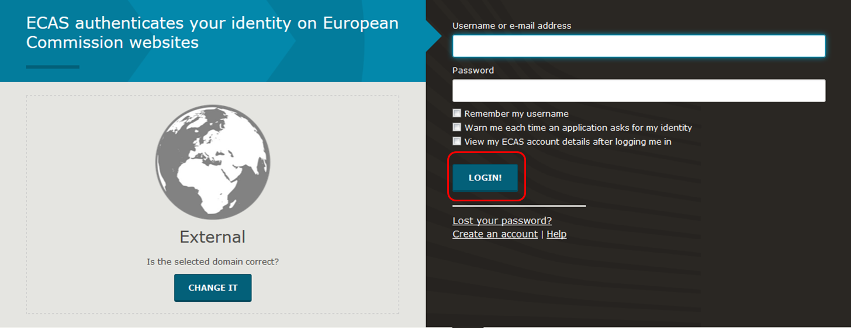

Password lost?
If you have lost your ECAS Password or you need to create a new one, click the hyperlink Lost your password? and follow the instructions.
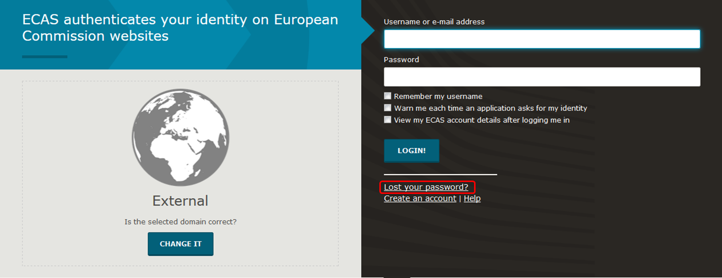

Create a new ECAS account.
In order to create a new ECAS account, click on the Create an account hyperlink and follow the instructions.
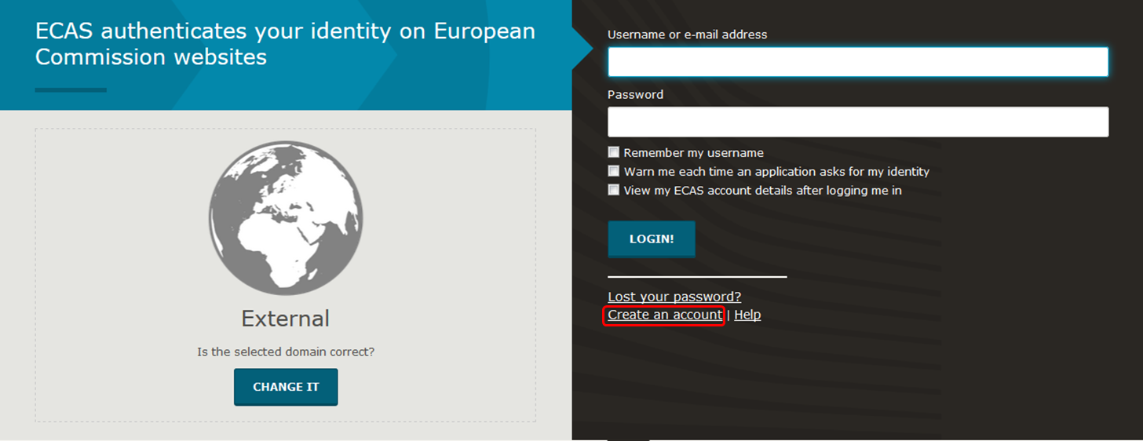

Help (Frequently asked questions).
If you need help or need to check the frequently asked questions, click the Help hyperlink.
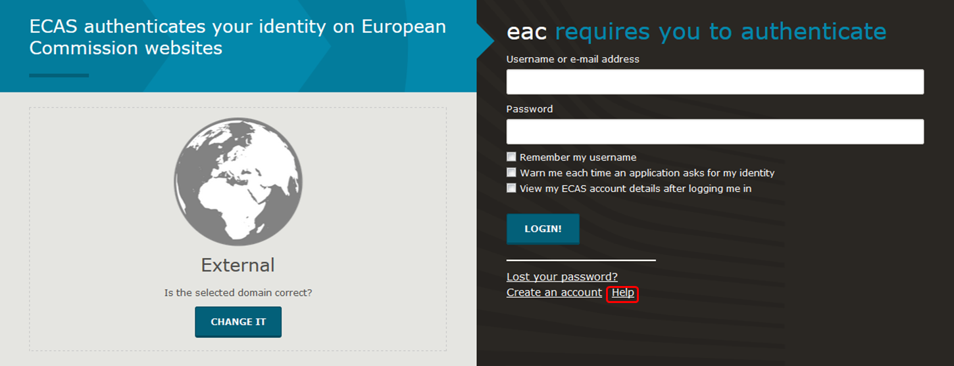

Automatic notifications
Notifications by default will be sent to the project contact of the beneficiary organisation as indicated in EPlusLink. The person who receives notifications can be changed in MT+ by indicating another contact from the beneficiary organisation as the Preferred contact. The notification by default is sent out in English and may also be sent out in the language of the National Agency if the translation of interface has been done for that language.

Creation of project in the Mobility Tool
On creation of a project in MT+, a notification will be sent to the project contact person of the beneficiary organisation. The email notification provides instructions on how to login in to MT+ using ECAS. If you do not have an ECAS account follow the instructions to register in ECAS first.
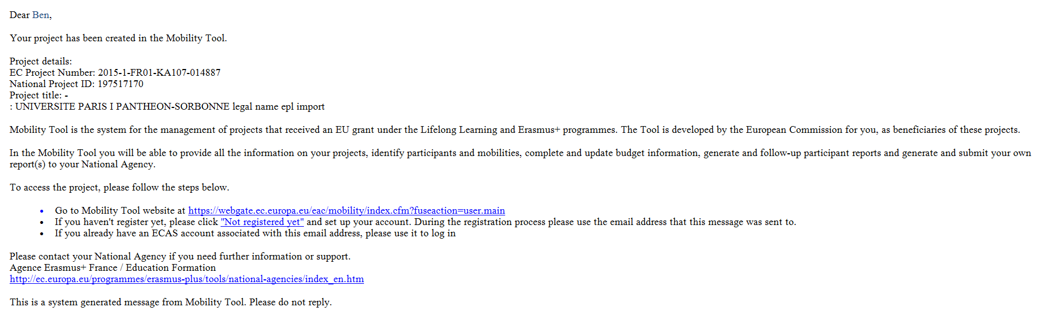

Project Update
When the project data has been updated in MT+, a similar message to the one below will be sent to the project contact. The project contact is indicated as the Preferred contact in MT+ and can be changed to another contact of the beneficiary organisation.
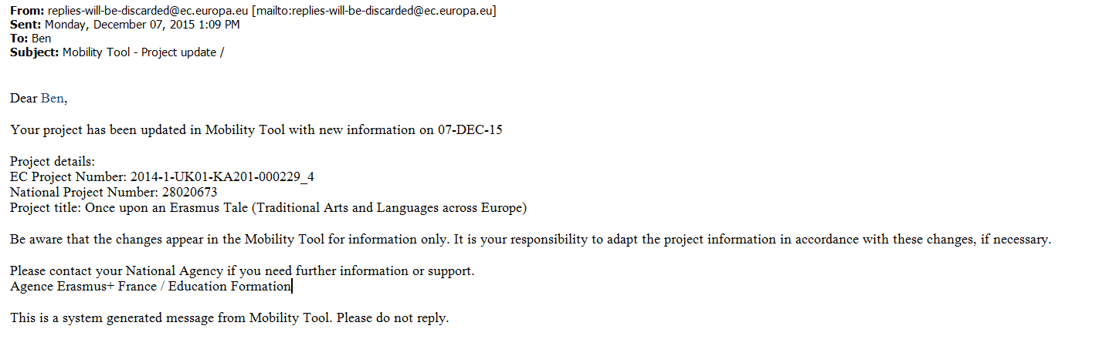

Menu and Navigation
- Home page.
- Difference between the link to projects for KA1 & KA3 and for KA2.
- Difference between the tabs for KA1 & K3 and for KA2.

Home page.

Explanation and illustration
Once logged to the tool, the home page is displayed as follows:
- The Project List window is displayed.
- The system allows you choosing amongst a list of different languages and changing the language of the interface.
- At the top middle of the screen, details of who is connected to the tool are identified.
- A sub-window, which provides a definition of the Mobility tool, is displayed.
- The project references are sorted depending on the programme and listed by the Grant Agreement No.
- For KA2 projects, the type of access you have for the project will be indicated next to the project reference.
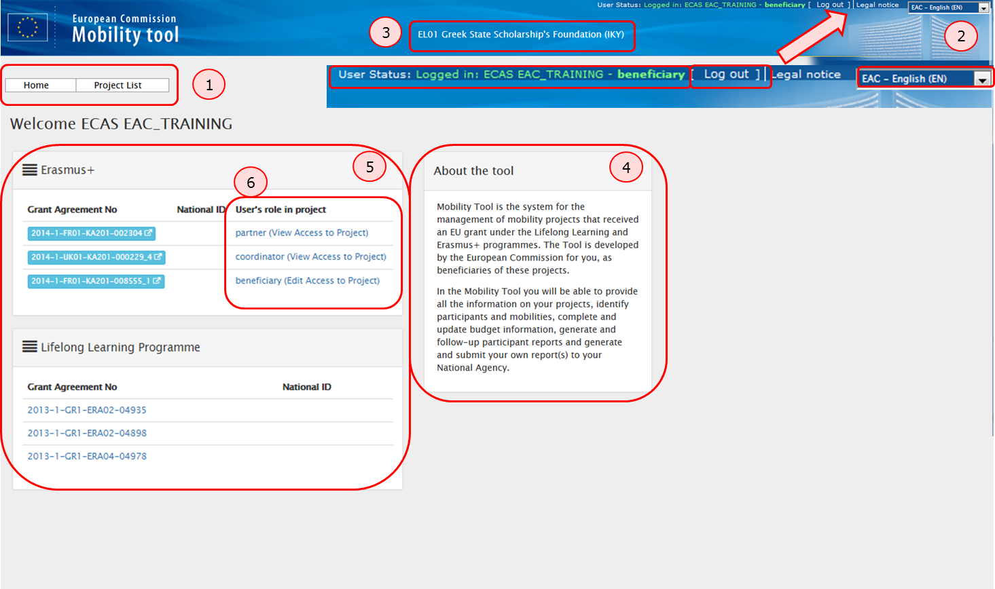

Difference between the link to projects for KA1 & KA3 and for KA2.

Explanation and illustration
Access to the KA1 or KA3 projects is different than for the KA2 projects.
- When a KA2 project is clicked from the Project List, the system opens a new browser page. Note that projects concerning KA2 are highlighted in blue.
- When a KA1 or KA3 project is clicked from the Project List, the system opens the project directly in the same browser page.
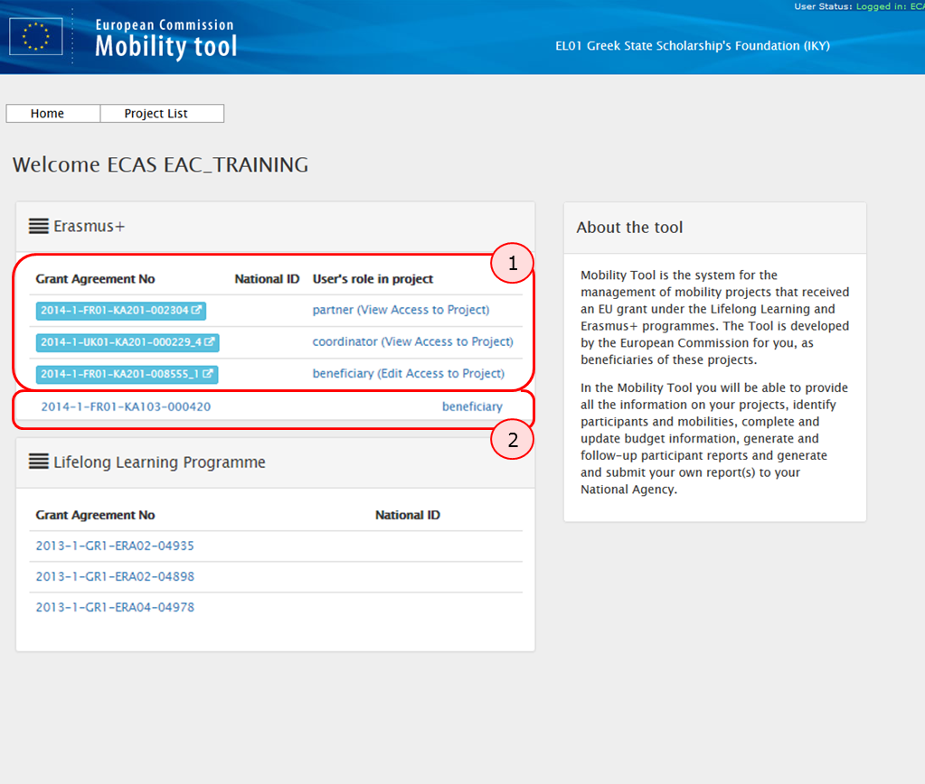

Difference between the tabs for KA1 & K3 and for KA2.

Explanation and illustration
The tabs for KA1 & KA3 are different than for the KA2.
The Tabs for KA1 & KA3 are displayed in a structure that organizes the mobilities management inside the Mobilities tab.

The Tabs for KA2 are displayed in a structure that splits different activities and management options between various tabs.

List functionalities
This page explains the common list functionality that are seen throughout MT+, for example the Organisations and Contacts tabs. The icons used to sort or export the list remain the same for each screen as well as the icons to edit, delete and view the list item.
- Search.
- Selection.
- Export.
- View.
- Edit.
- Delete.
- Back to list.

Search.
In order to find information quickly in each tab of the menu, type, for example, the name of the organisation in the Search field.
The result will appear in the list.
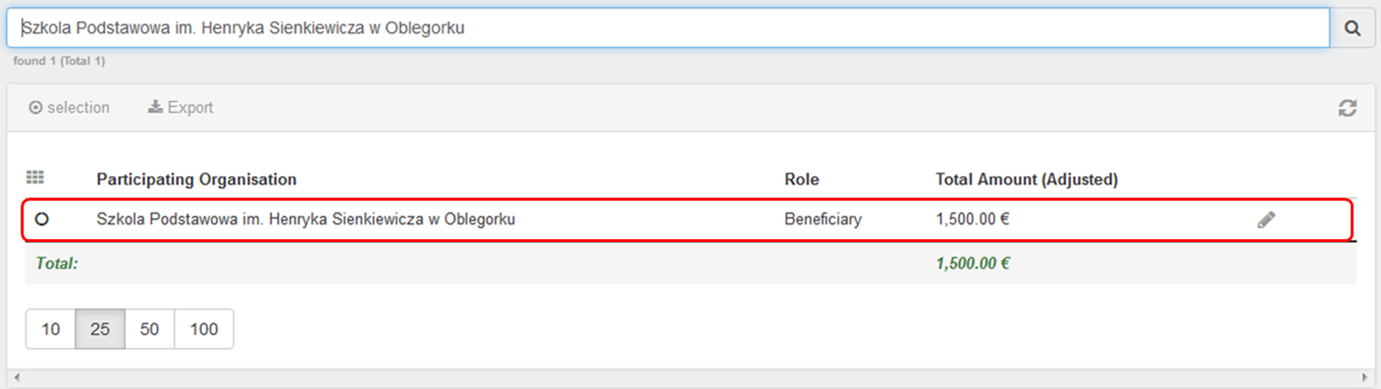

Selection.
The Selection option allows you selecting or de-selecting all detail lines.
By clicking on the radio button, you can select following options: All, NONE or inverse.
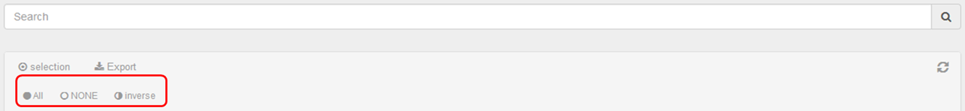
In the example below, the option All is selected.
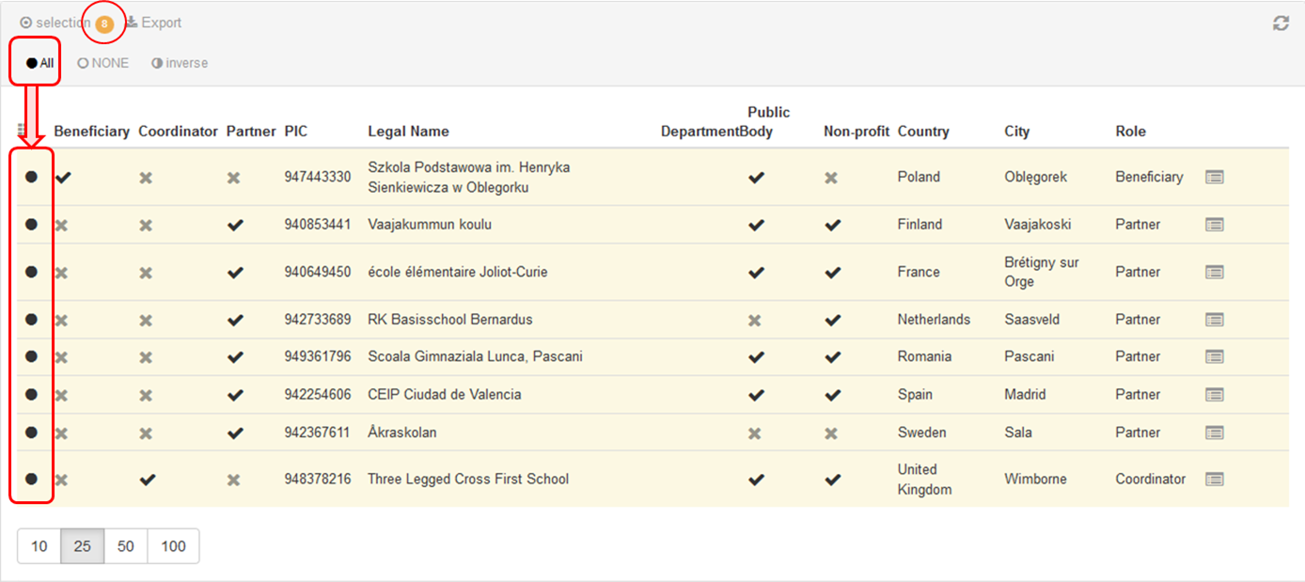
Depending on the tab, where you select data, the button Delete records appears.
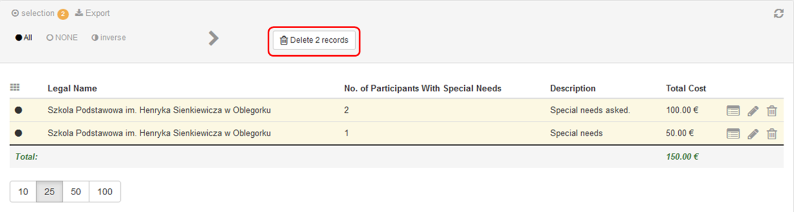

Export.
The Export button allows you exporting your selection and choosing a format amongst the three following options: PDF File, XLS file or CSV file.
In the example below the PDF File format has been clicked.
A pop-up message will appear allowing you to open the pdf file.
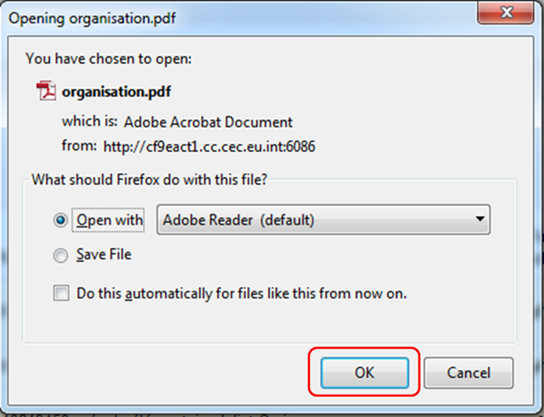

View.
To view the details of a line, click the view icon.
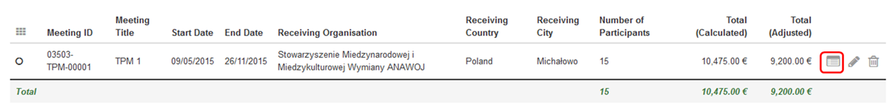
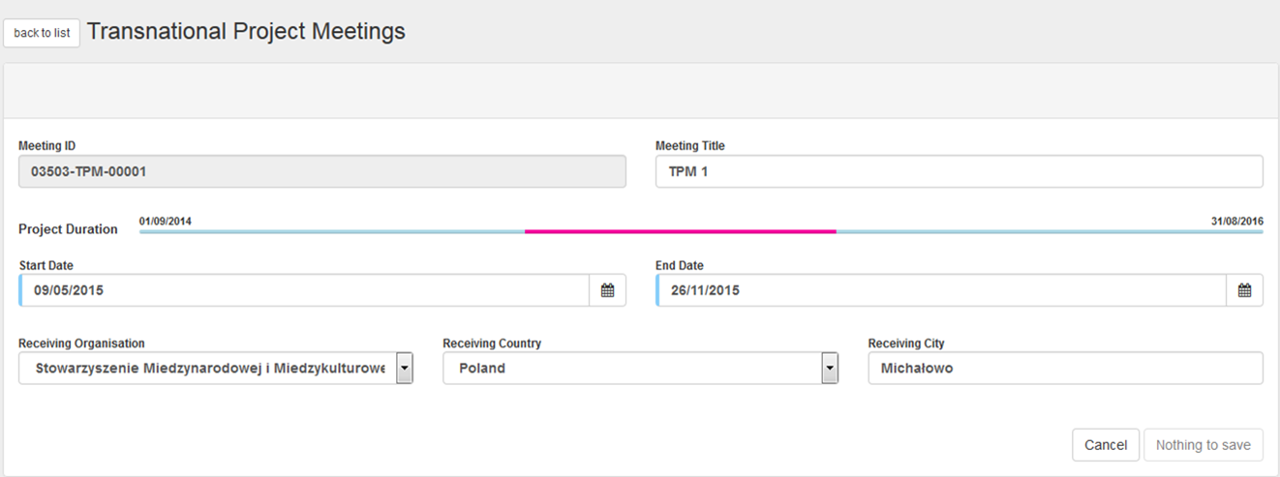

Edit.
To edit the details line, click the pencil icon.
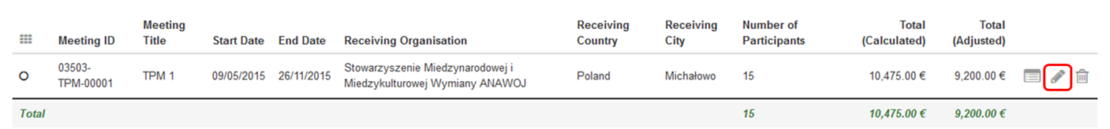
A window showing details will open. Here the fields can be edited.
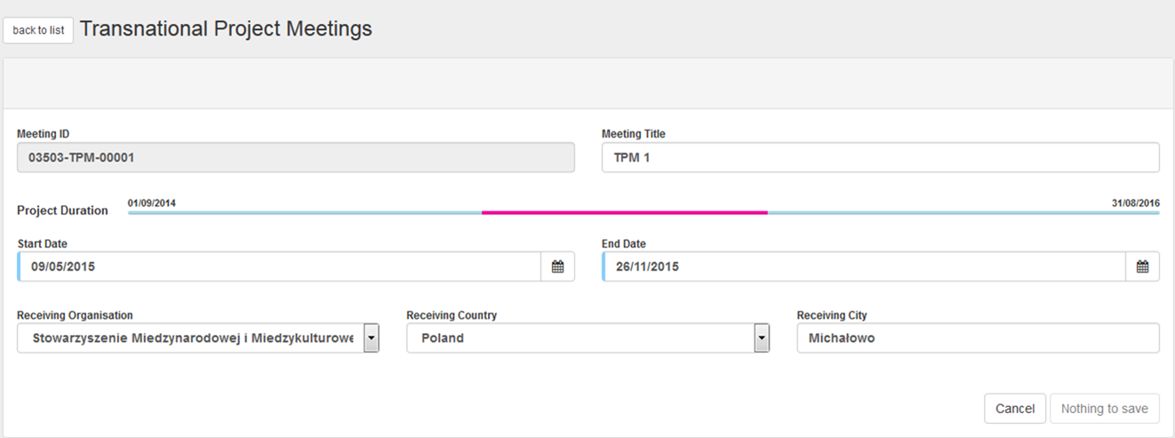

Delete.
To delete the details line, click the bin icon.
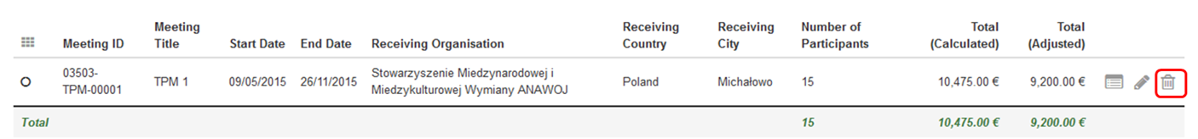

Back to list.
In order to get back to the list of details, click the back to list button.
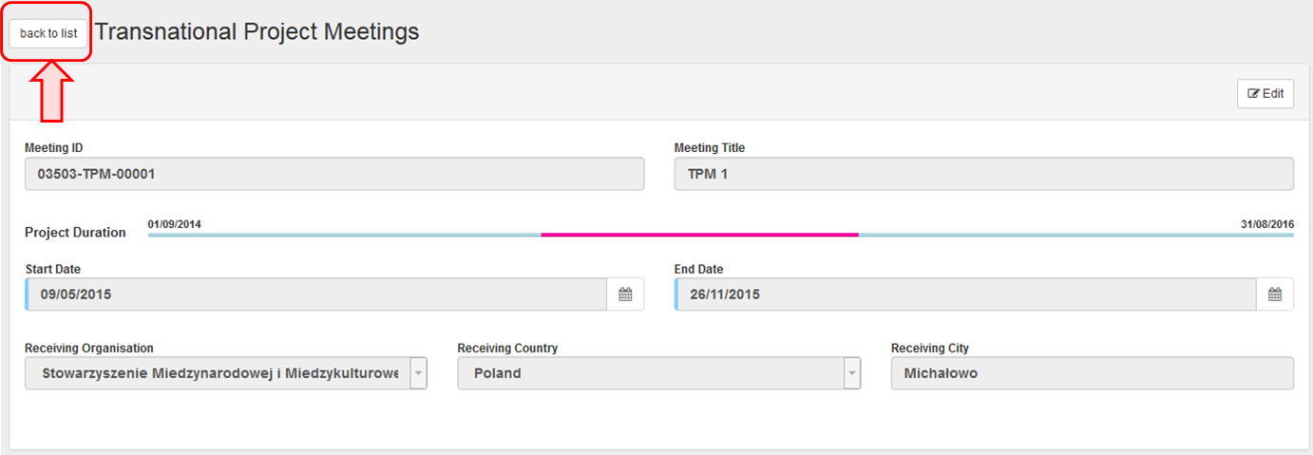

You will be redirected to the list of detail line(s).
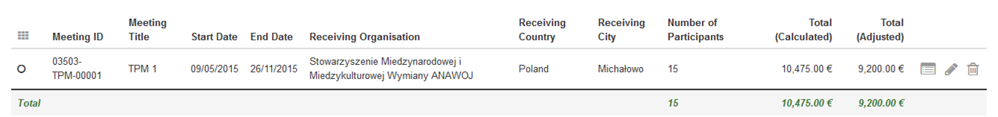

Project Details
The page should be marked by one of the 6 statuses. The page is either in DRAFT or is ready for or undergoing REVIEW. After review if there are comments or changes required the page is marked with the status CHANGES. If reviewed or not reviewed and no comments provided, the page is considered ready to be published and the status will be indicated as such READY. Finally the page is PUBLISHED. The page may be hidden from the NA user group once it is AGED but may remain on this wiki for reference.
- "Project Details" page.
- Changes to "Project Details".

"Project Details" page.

Explanation and illustration
Once you click on the project's Grant Agreement No from the MT+ homepage, a new screen will open displaying the Project Details.
The key details of the project are structured in the following fields: Context information, National Agency, Project information, Beneficiary Organisation information and Project Access. The screen also presents History information, giving details of the creation of the project in MT+, last update and person (or system) that updated the project last.
Note that the tabs listing Project Details for KA1 & KA3 are different than for KA2 projects, however, the content fields are the same. See more information about the differences in the Project Details screen interface for KA1 & KA3 and for KA2 projects in the page Menu and Navigation.
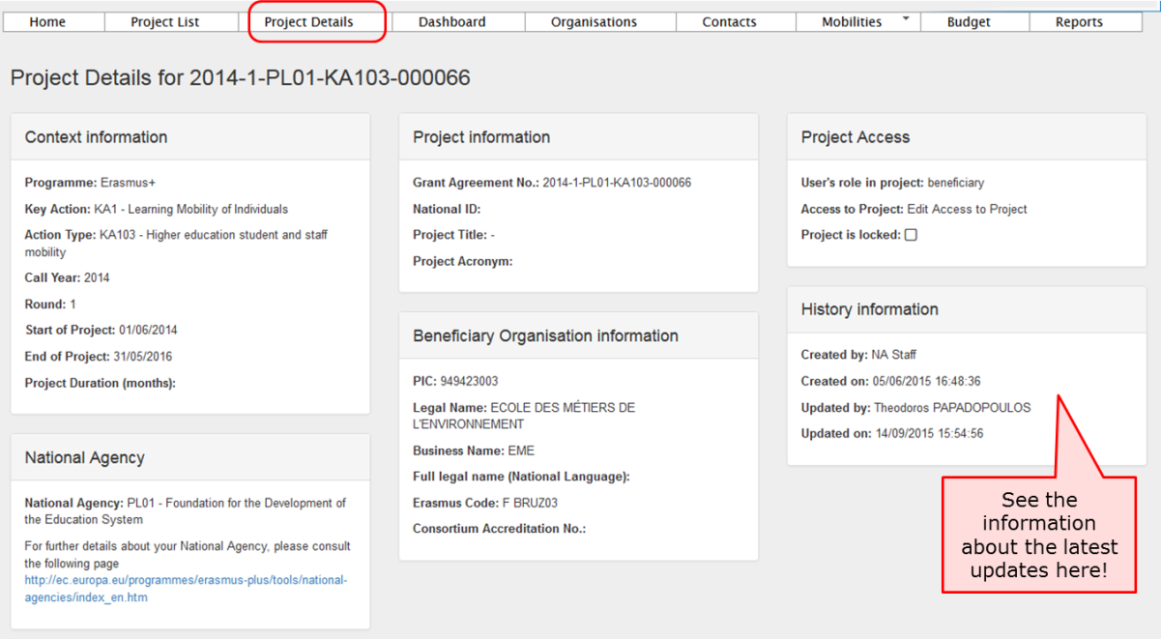

Changes to "Project Details".

Explanation and illustration
The project details such as: the Project Title, the National ID, the Start and End of Project cannot be changed in the tool. To request changes to these project details, please contact your National Agency.
It is possible to add and remove Contacts, Mobilities and Participants, as well as to edit the current Budget information. See more information about editing details in various How-to pages of the guide.

How to manage organisations
For most key actions the organisation details can not be changed in MT+ but should follow the process of an amendment.
Organisation details that are entered into URF (URF and Participant Protal guide) should first be updated there before the National Agency will be able to adjust the details in EPlusLink.
Once changes have been applied, the updated data will be sent to MT+.
The contact person of the beneficiary or coordinating organisation will receive a notification once the updated information is sent to MT+.
- Open the list of "Organisations".
- View organisation details.
- Organisation details are not updated?.
- Edit organisation details.

Open the list of "Organisations".
From the list of tabs, click on the Organisations menu item.
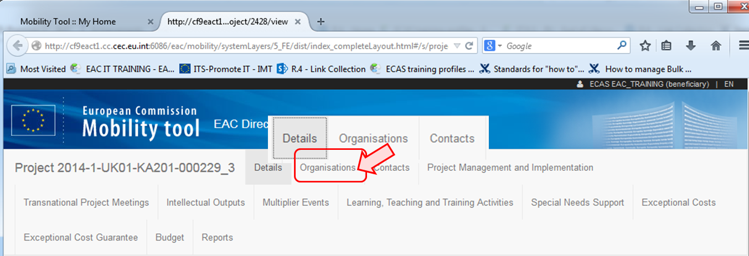
The list of Organisations will appear.
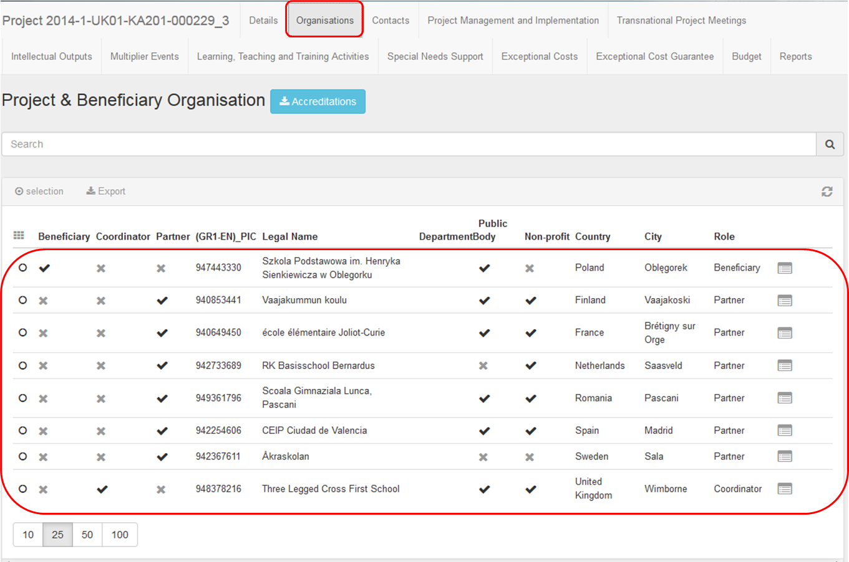

View organisation details.
Click on the view icon to open Organisation Details screen.
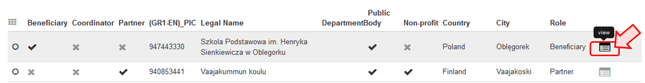

Organisation details are not updated?.
The organisation details for most key actions will be updated as a result of an amendment request and should first be updated in URF and then by the NA in EPlusLink.
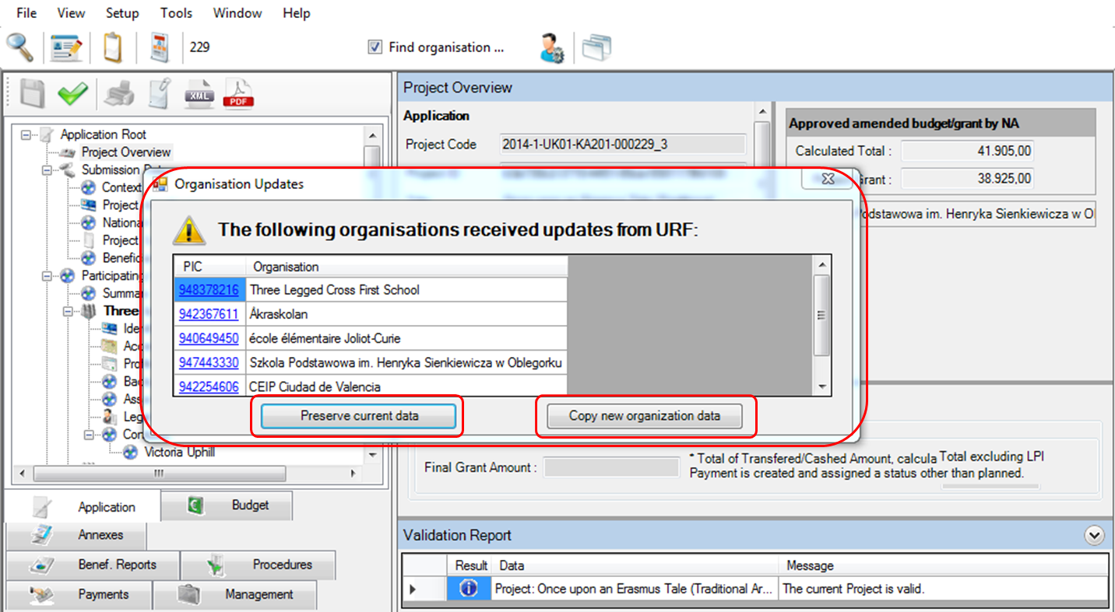

Edit organisation details.
For certain Key actions e.g. KA103 and KA107 additional organisation details can be added. These "host" organisations can be managed by the beneficiary organisation.
In this case additional icons will be present on screen to allow editing (pencil icon) or deletion (bin icon) of the organisation.
Please note that you can not delete an organisation if it is associated to a mobility or activity.
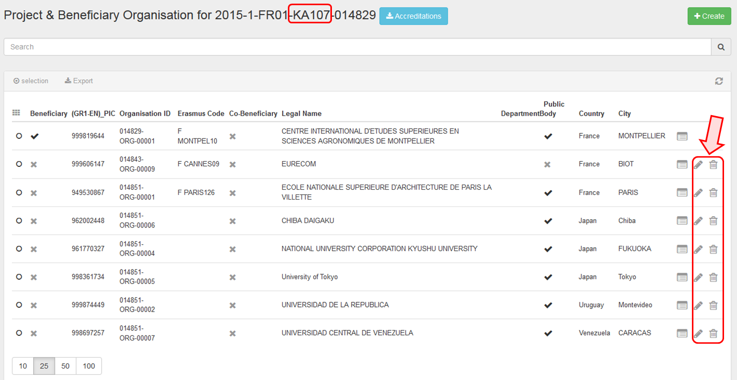

How to manage contacts
The project contact as indicated in the application form will automatically receive an email when the project is created in the Mobility Tool+. The project contact can create additional users for the organisations. Edit access can be given to other contacts of the coordinating or beneficiary organisation. View access to the project can also be given for KA2 projects.

Quick steps
- 1. Click the project reference.
- 2. Click the "Contacts" menu item.
- 3. Click the "+Create" button.
- 4. Fill in the details
  - 4.1. Select the organisation.
  - 4.2. Allow access to project?
  - 4.3. Indicate as "Preferred Contact"?
  - 4.4. Indicate as "Legal Representative"?
  - 4.5. Contact details are the "Same as Organisation"?
- 5. Click on "Save".
- 6. Click on Delete icon.

Detailed steps
- Click the project reference.
Click on the project reference to open a project.
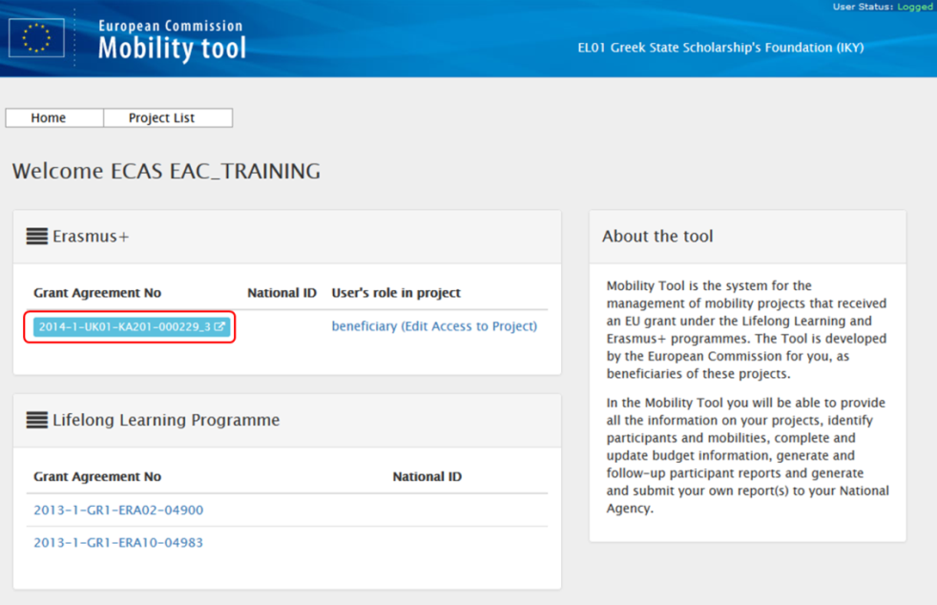
- Click the "Contacts" menu item.
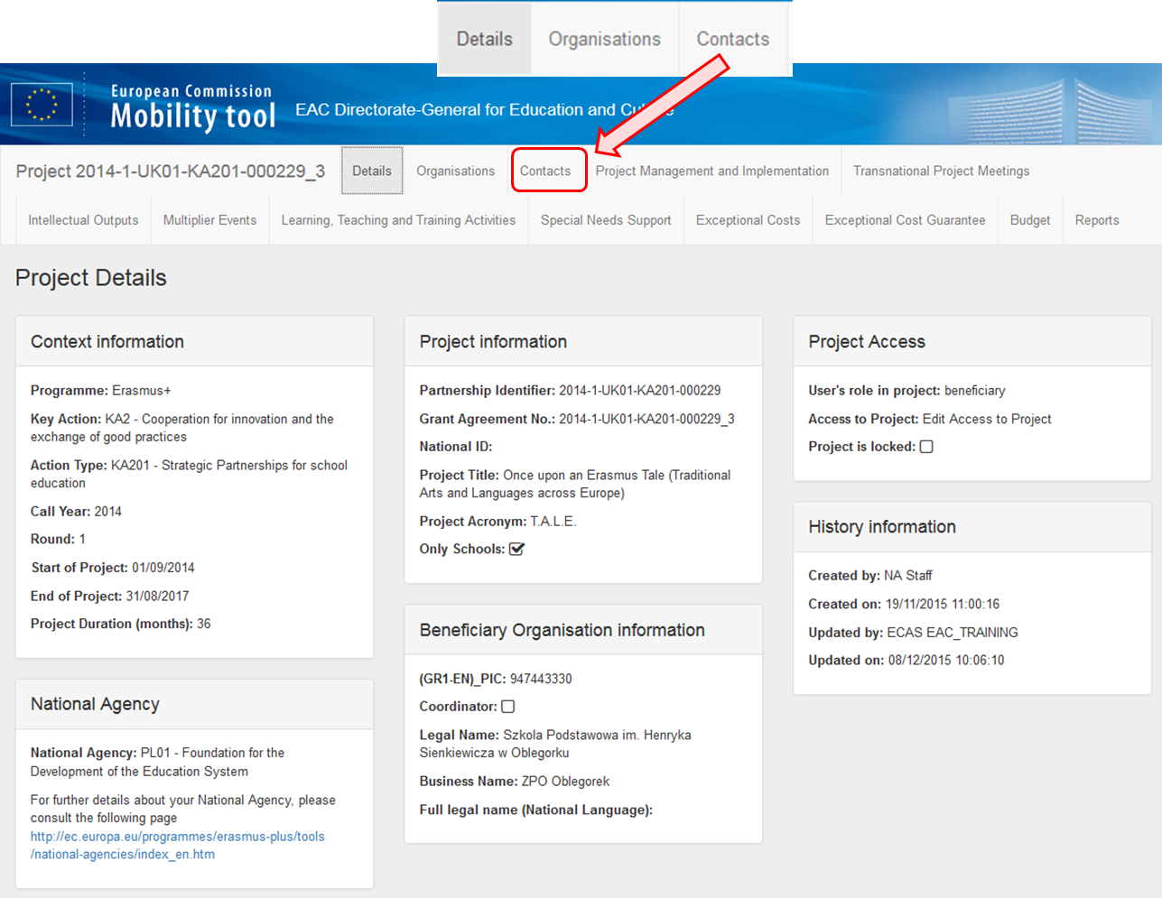
The list of contacts appears. The full list of project contacts as entered in the application form will be entered here.
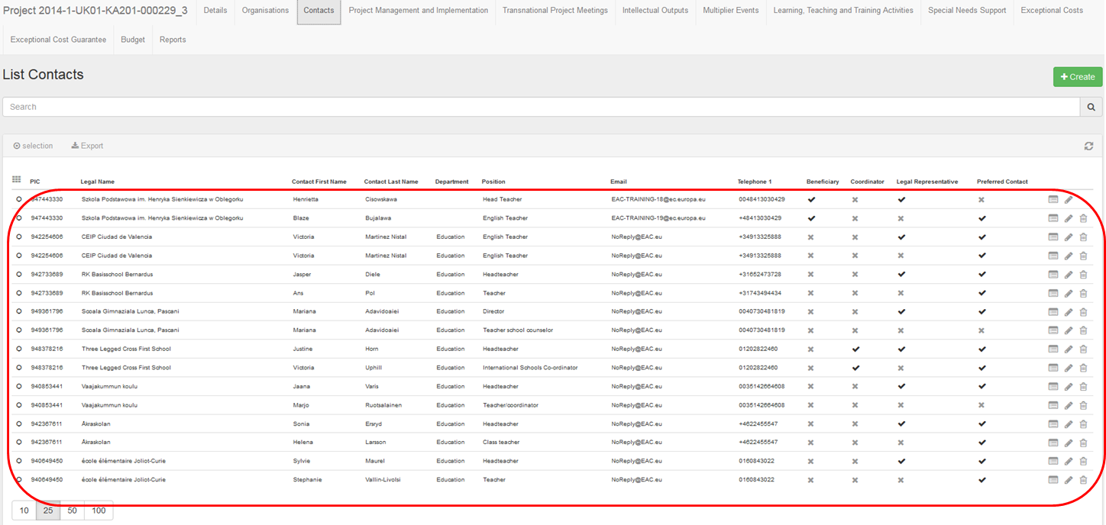
- Click the "+Create" button.
To add a new contact click on the "+Create" button and complete the contact details.
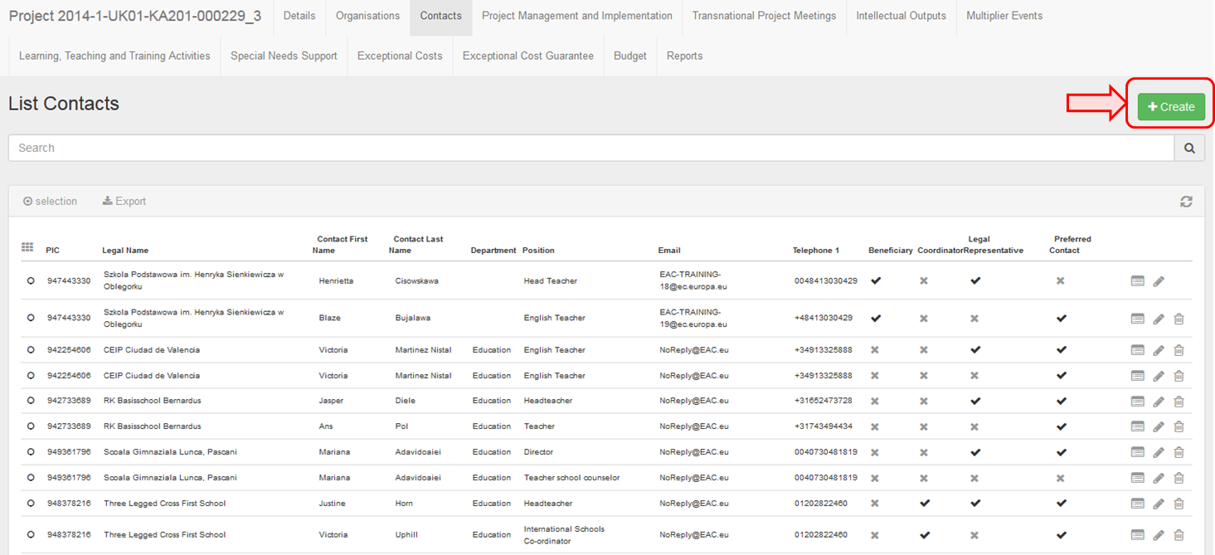

- Filll in the details.

4.1. Select the organisation.
Select the organisation from the drop down list. This will affect the check boxes that are active.
The Legal representative check box is not active for the beneficiary organisation. Only once the contact is indicated in the National Agency's project management system EPlusLink as a legal representative will the box be checked.
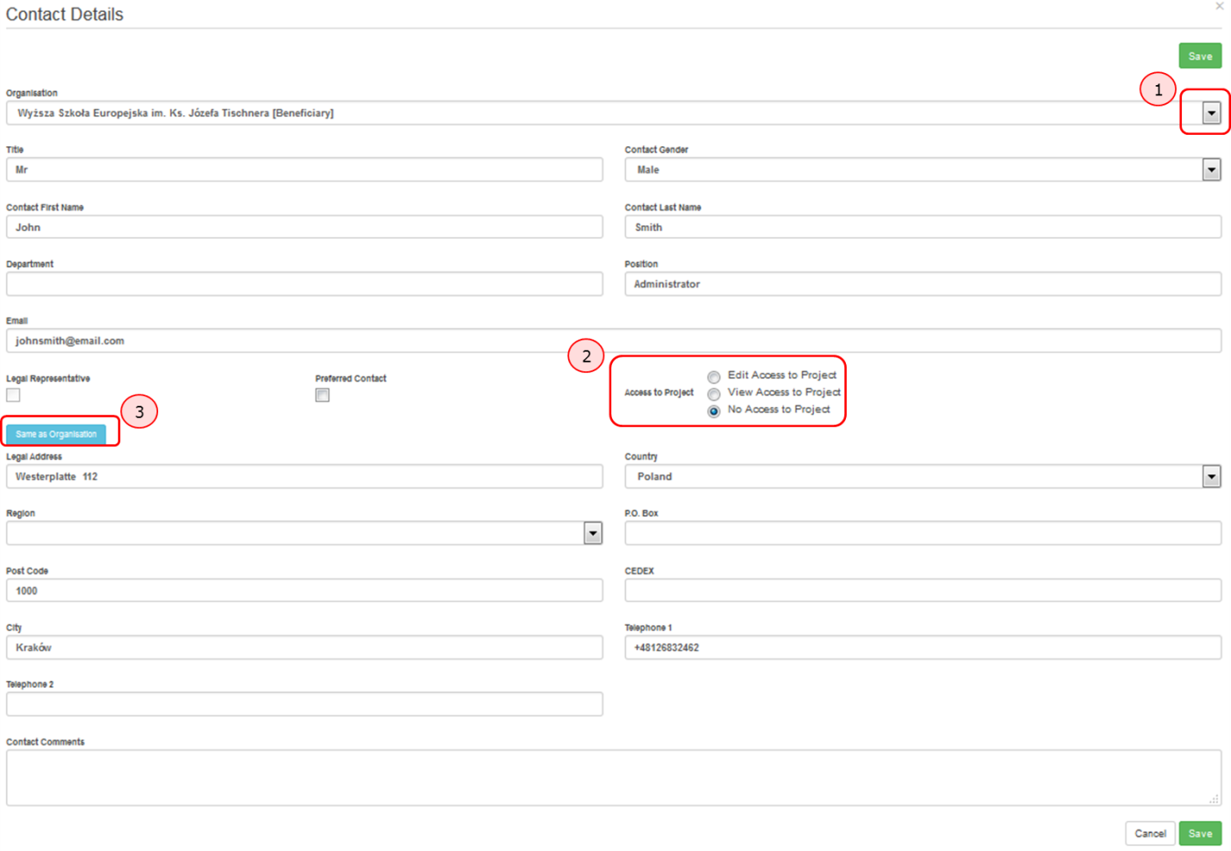

4.2. Allow access to project?
Depending on the organisation you select, several Access to Project options (check boxes) may be available. Check the box the option to allow the contact edit or no access to the project details in MT+.
For KA1 and KA3 projects, it is only possible to allow contacts of the Beneficiary organisations edit access.
For KA2 projects (excluding those as indicated as schools only) a contact from a participating organisation may be provided access to view the project but will not have access to edit the project details.
For KA201 indicated as schools only the participant organisations contacts can be given access to view the coordinator's project. The contacts from the coordinating organisation can be given access to view all participating organisations' projects.

parti participating organisations' projects.

4.3. Indicate as "Preferred Contact"?
Checking the box Preferred Contact will highlight the contact, in the organisation list, as the preferred person for that organisation. There can only be one preferred contact per organisation. For the beneficiary organisation the preferred contact will receive the automatic notifications when the project data is updated in EPlusLink and resubmitted to MT+ by the National Agency. By default this is the project contact as outlined in the application form but may be changed to a newly created contact for the beneficiary contact person in MT+.

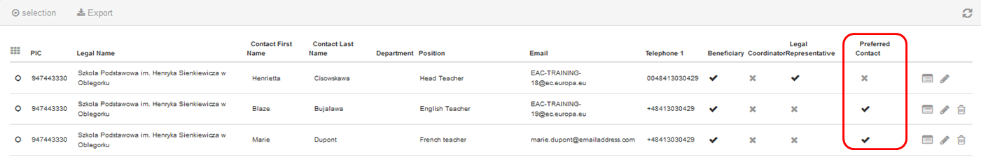

4.4. Indicate as "Legal Representative"?
Please note that the legal representative details can not be adjusted in MT+. To adjust the legal representative details please follow the amendment process.
Legal representative check box is not active. Only once the contact is indicated in the National Agency's project management system EPlusLink as a legal representative will the box be checked.

4.5. Contact details are the "Same as Organisation"?
Click on "Same as Organisation" to copy the organisation address and phone details to the contact's details.
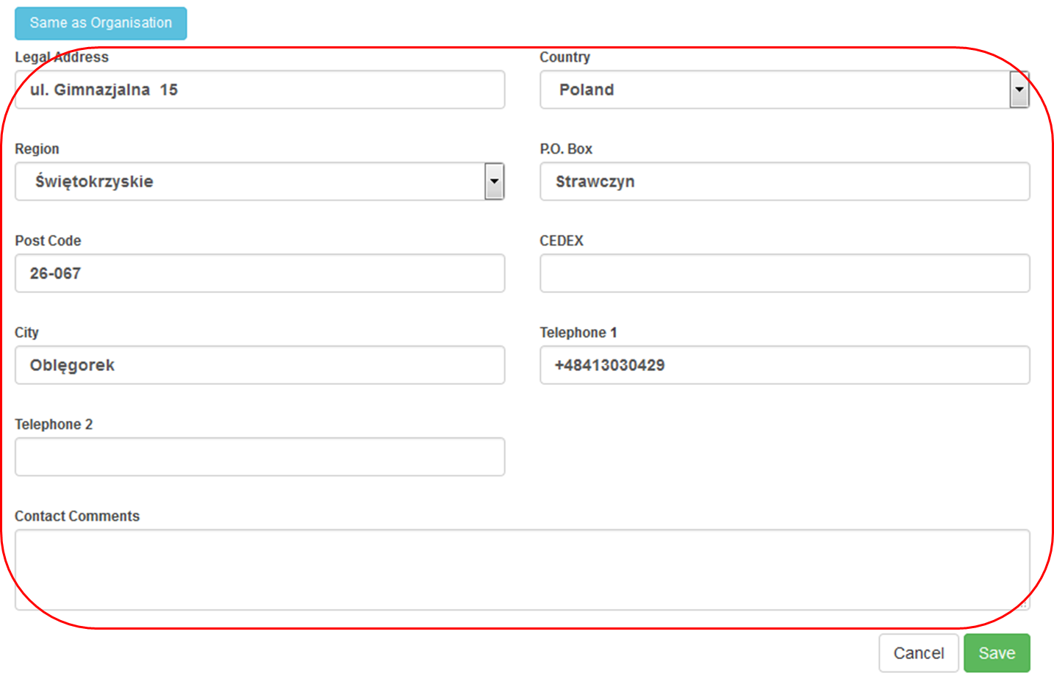

4.3. Indicate as "Preferred Contact"?
Checking the box Preferred Contact will highlight the contact, in the organisation list, as the preferred person for that organisation. There can only be one preferred contact per organisation. For the beneficiary organisation the preferred contact will receive the automatic notifications when the project data is updated in EPlusLink and resubmitted to MT+ by the National Agency. By default this is the project contact as outlined in the application form but may be changed to a newly created contact for the beneficiary contact person in MT+.

4.4. Indicate as "Legal Representative"?
Please note that the legal representative details can not be adjusted in MT+. To adjust the legal representative details please follow the amendment process.
Legal representative check box is not active. Only once the contact is indicated in the National Agency's project management system EPlusLink as a legal representative will the box be checked.

4.5. Contact details are the "Same as Organisation"?
Click on "Same as Organisation" to copy the organisation address and phone details to the contact's details.
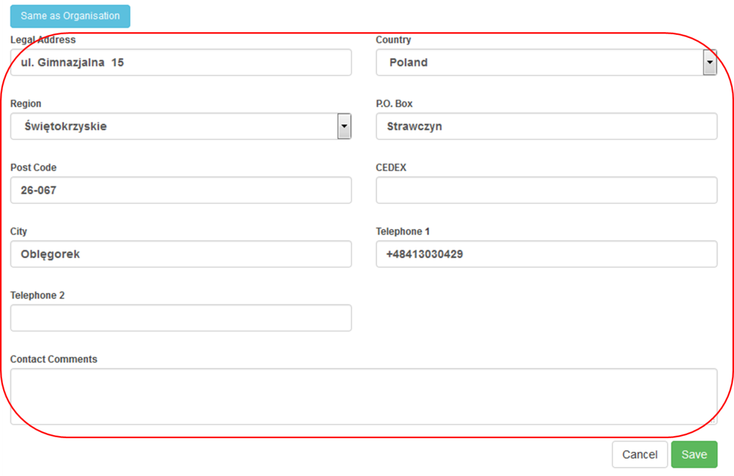

- Click on "Save".
To save the data, click the "Save" button.
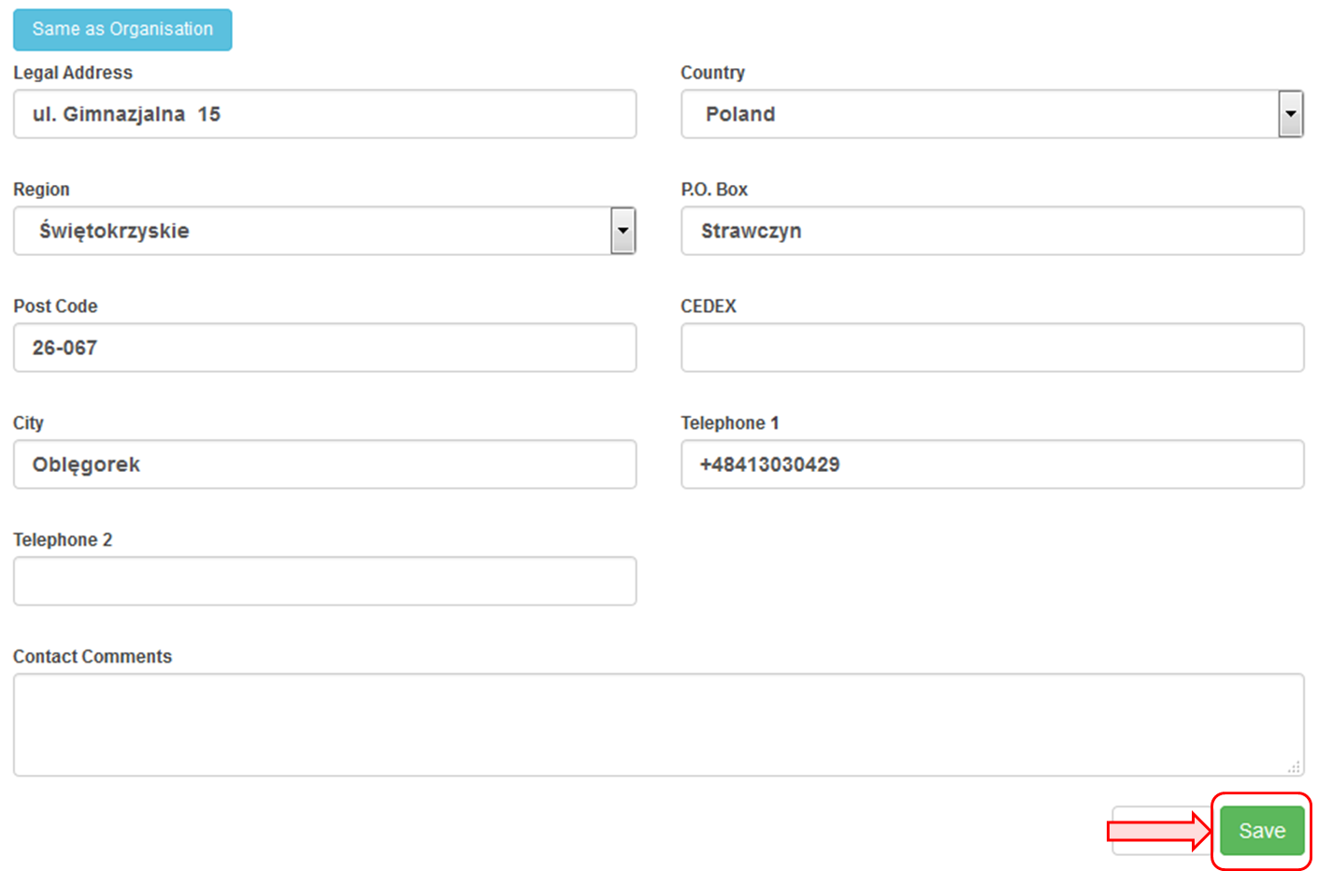

- Click on Delete icon.
Click on the bin icon to delete a contact.
Please note that the legal representative can not be deleted.
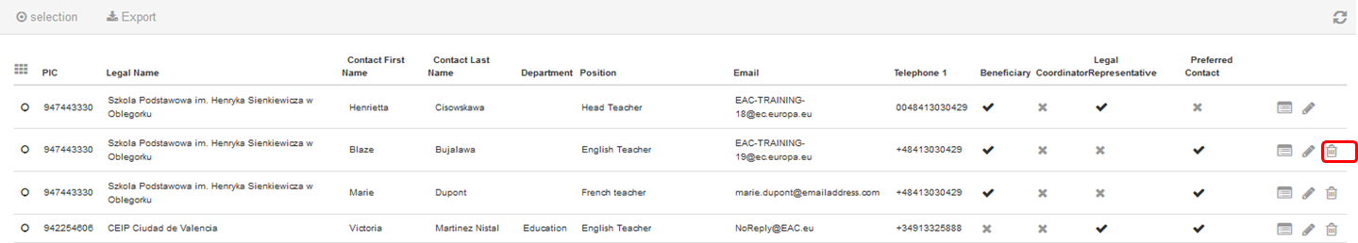

How to manage mobilities for KA1 and KA3 projects

What are KA1 and KA3 mobilities?
Each Erasmus+ key action is divided into different action types depending on the intended programmes objectives and target groups. Activity types therein further divide such action types into homogeneous groups of participants encoded as mobilities within Mobility Tool. Mobilities represent the sending of a particular individual from an origin country to a destination country typically within the set of Erasmus+ programme countries. Depending on the activity type concerned each participant in an Erasmus+ mobility is entitled to receive funds for travel, individual support, special needs, exceptional costs, etc. Mobility tool allows Beneficiary Organisations to manage all this information in a coherent and meaningful manner.
Videos not available in pdf, word or print format
These videos add here for this chapter can not be printed. All of these videos but were made available to the National Agencies last year to be distributed via their own channels.

How to add a mobility
Length of video | Version of Tool | Comments
7min 03sec | MT+ 1.7.1 | This video was created using screenshots from MT+ 1.7.1. Deviations from the current screen layout and that of this older version may be noted but the basic functionality remains the same.  This process describes the steps to be performed by a beneficiary user in order to add a mobility using the interface of MT+.  The scenario used in this video demo is based on the addition of mobility for a higher education project KA103, for activity type Student mobility for studies between programme countries. Some fields are only relevant for KA103. Fields, which are required for other action types or activity types, will be missing from this scenario.

Video

URL: How to add a mobility
QR code:

How to export and import mobilities
Length of video | Version of Tool | Comments
10min 16sec | MT+1.7.1 | This video was created using screenshots from MT+ 1.7.1. Deviations from the current screen layout and that of this older version may be noted but the basic functionality remains the same.  This process describes the steps to be performed by a beneficiary user in order to add a mobility using the interface of MT+.  The scenario used in this video demo is based on the addition of mobility for a higher education project KA103, for activity type Student mobility for studies between programme countries. Some fields are only relevant for KA103. Fields, which are required for other action types or activity types, will be missing from this scenario.

Video

URL: How to export and import mobilities
QR code:

How to read the error log
Length | Version of Tool | Comments
5min | MT+1.7.1 | This video was created using screenshots from MT+ 1.7.1. Deviations from the current screen layout and that of this older version may be noted but the basic functionality remains the same.  This process describes the steps to be performed by a beneficiary user in order to add a mobility using the interface of MT+.  The scenario used in this video demo is based on the addition of mobility for a higher education project KA103, for activity type "Student mobility for studies between programme countries". Some fields are only relevant for KA103. Fields which are required for other action types or activity types, will be missing from this scenario.

Video

URL: How to read the error log
QR code:

How to work with CSV
Length | Version of Tool | Comments
6min 24 sec | MT+1.7.1 | This video was created using screenshots from MT+ 1.7.1. Deviations from the current screen layout and that of this older version may be noted but the basic functionality remains the same.  This process describes the steps to be performed by a beneficiary user in order to add a mobility using the interface of MT+.  The scenario used in this video demo is based on the addition of mobility for a higher education project KA103, for activity type "Student mobility for studies between programme countries". Some fields are only relevant for KA103. Fields, which are required for other action types or activity types, will be missing from this scenario.

Video
URL: How to work with CSV

QR code:

How to manage activities for KA2 projects

What about KA2 Strategic Partnerships?
Strategic partnerships' projects are also supported by Mobility Tool. Although not managing pure mobilities such projects need to be managed in terms of the outcomes and results they produce especially for those projects mostly concerned with development of innovation. Therefore Mobility Tool provides all needed functionality to create and manage a KA2 project allocation of funds for project management and implementation, transnational project meetings, intellectual outputs and associated multiplier events and individuals participating in learning, teaching and training activities, the latter mostly relevant for projects targeting exchanges of practices. The filling in and submission of final report by Beneficiary Organisations and subsequent validation by National Agencies is also available for KA2.

Project Data
When the project is created in MT+, project information is populated under the various tabs, such as organisations and contacts. The budget approved can be viewed from the budget tab. Details of the activities for Project Management and Implementation (PMI), Intellectual Outputs (IO), Multiplier Events (ME) and Learning, Teaching and training activities (LTT) are listed but do not contain the cost values for these activities. These items can be edited under the respective tabs. These items may be updated by the National Agency as a result of Amendment request or check of grant beneficiary.
Most cost values are calculated automatically in these screens after the number of participants or distance band is entered.

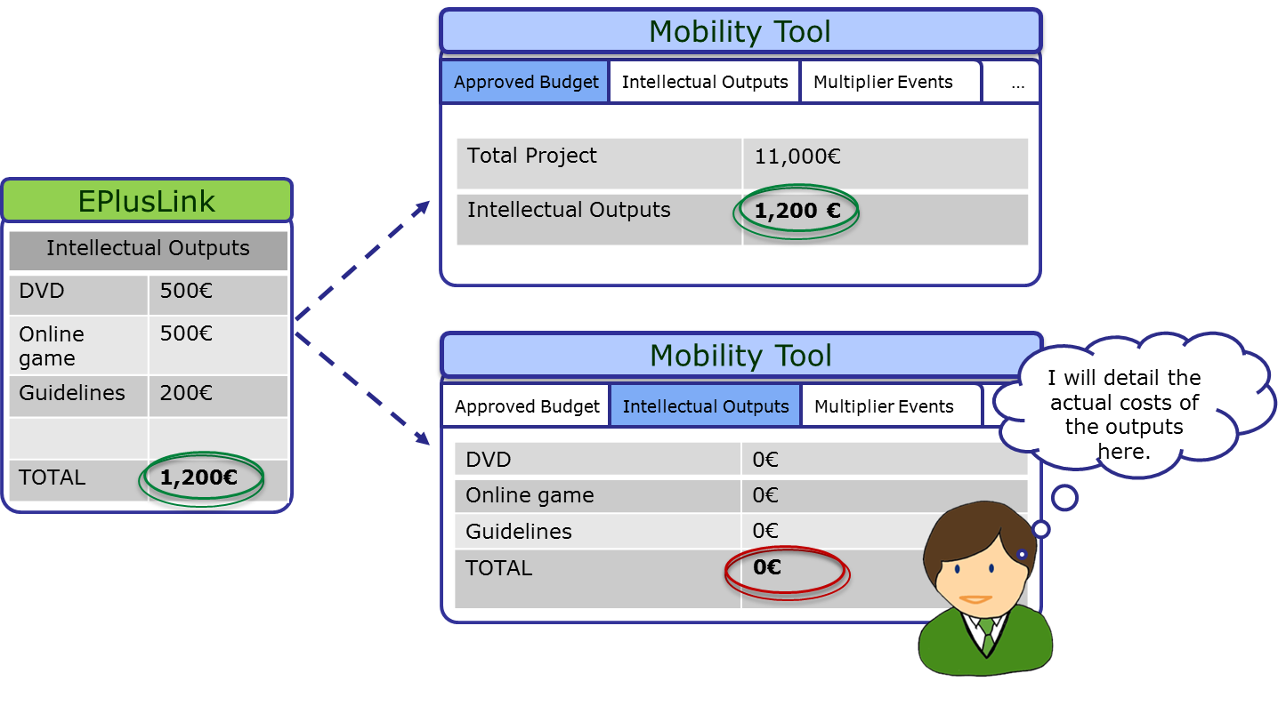
The “Central Rates Web service” is responsible for the validation and calculation of such costs as the travel grant, individual support, organisational support, linguistic support, course fees unit, all top-ups and total amounts. This allows to keep validation rules and calculation formulas harmonised across different IT systems.
Most tabs open to a list view, displaying the activities or items. In many cases, the activities when opened or edited may contain additional lists of items such as participating organisations, attendees or resources. Likewise, when creating new items, you may notice that first the basic information such as title or location should be saved and only then will it be possible to add the list of participants or organisations.
The functionality for these lists are explained in the section List functionalities. How to complete the details is explained under the various How to pages.

Who can manage or view the project?
For KA2 projects by default the person who is indicated in the application form as the project contact of the coordinating organisation, will have access to view and edit the project details. Partner contacts may also be given view access to the project.
For KA201 indicated as schools only, the organisations contacts may have view or edit access to their projects and view access to the coordinators project. The coordinating organisation's contacts may have view access to all partner organisations.

Project Management and Implementation
The Project Management and Implementation screen allows to record costs for project management activities such as: planning, finances, coordination and communication between partners.

Quick steps
- 1. Click on the project reference.
- 2. Click on the Project Management and Implementation tab.
- 3. Select the participating organisation.
- 4. Click on the pencil (Edit) icon and enter the Total (Adjusted) amount.
- 5. Click on the save icon.
- 6. Add a comment.

Detailed steps
- Click on the project reference.
From the homepage click on the project reference to open the project.
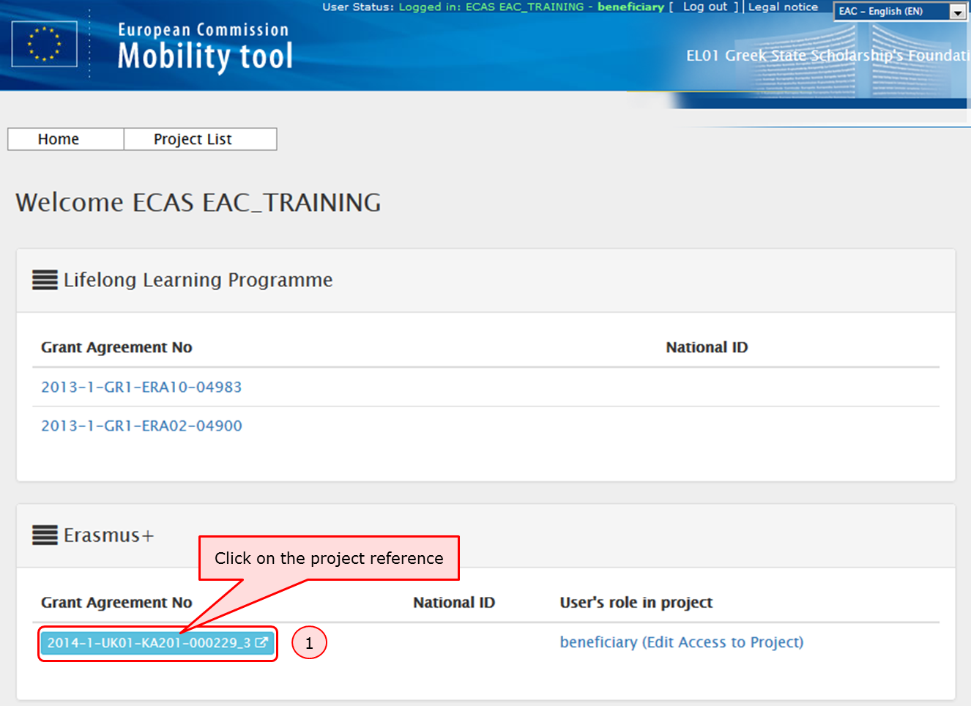

- Click on the Project Management and Implementation tab.
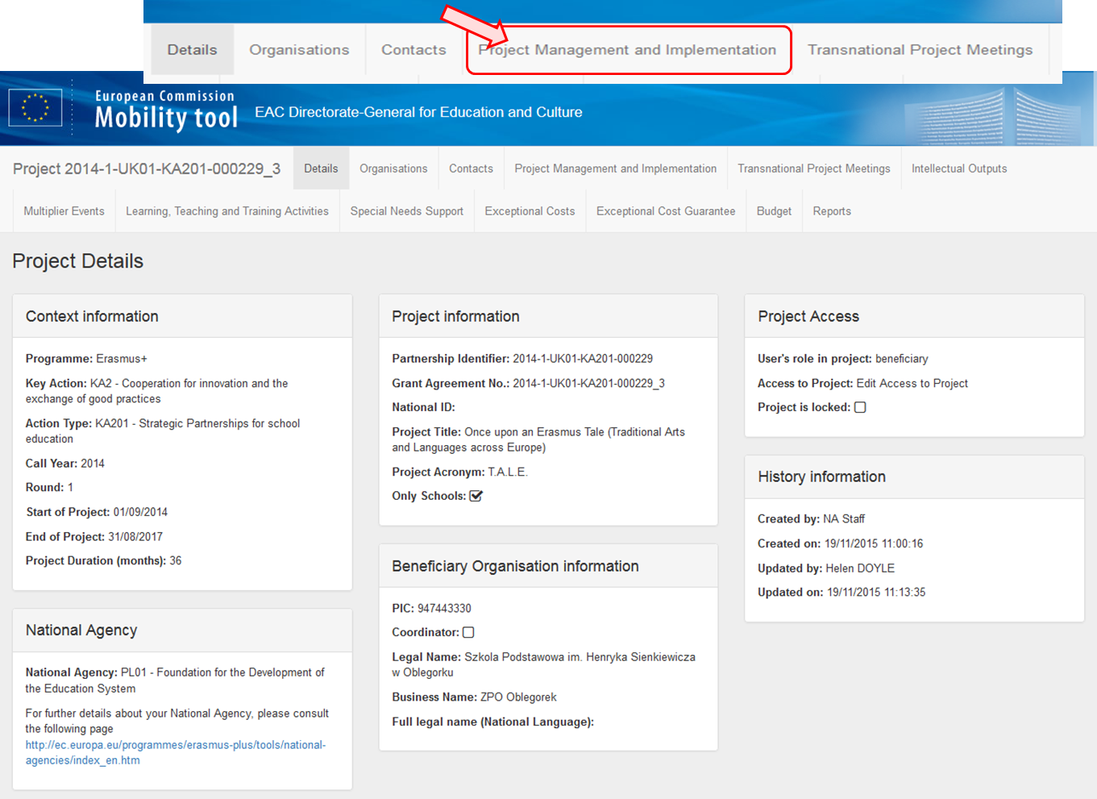
- Select the participating organisation.
Select the organisation for which the PMI costs are being allocated.
This section contains information about the contributions to the participating organisations' activities such as project management (planning, finances, coordination and communication between partners, etc.) according to the specific project contracted duration.
The PMI's entered into National Agency's project management system EPlusLink will appear in this list detailing only the participating organisation.
All additional information will have to be added by editing the selected PMI item. The total approved amount for this item can be viewed in the budget summary screen.
The total adjusted amount for all organisations should not be greater than the approved amount or less than 80% of the approved amount.
For school to school only projects only the beneficiary organisation will be listed here.
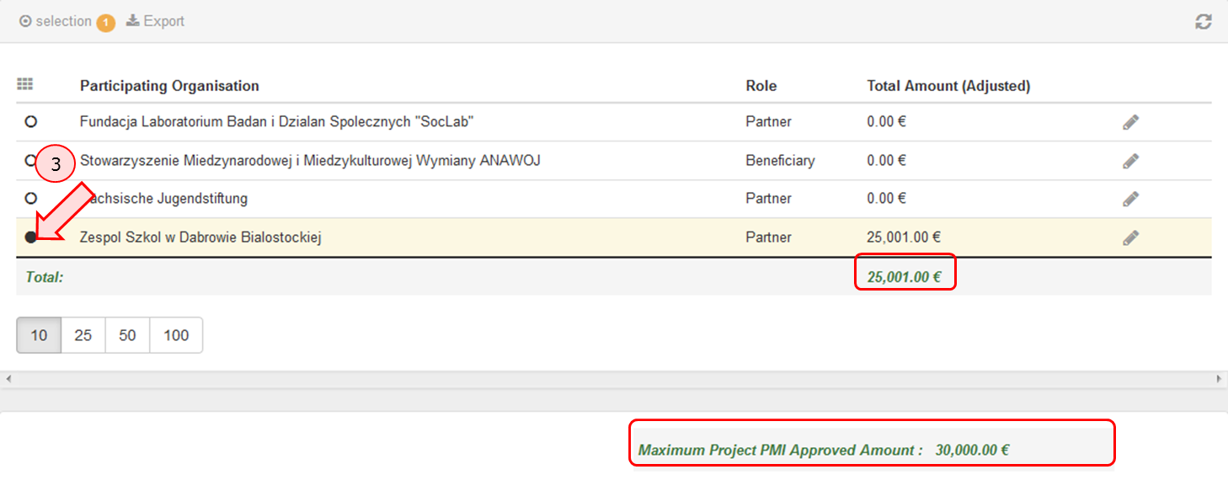
- Click on the pencil (Edit) icon and enter the Total (Adjusted) amount.
Enter manually the total PMI contribution to the activities of the specified organisation:
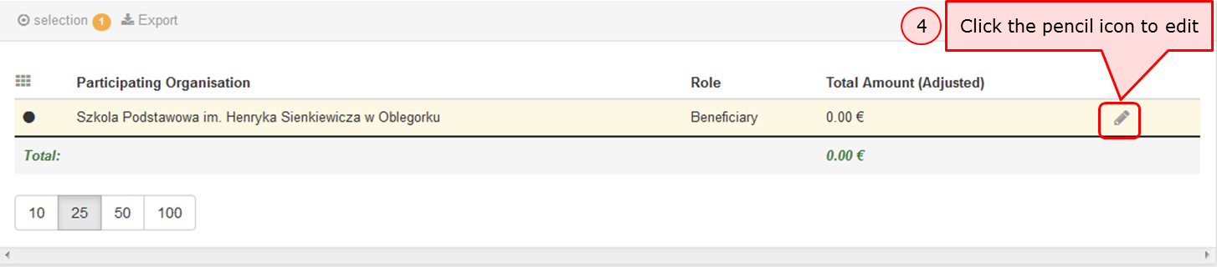
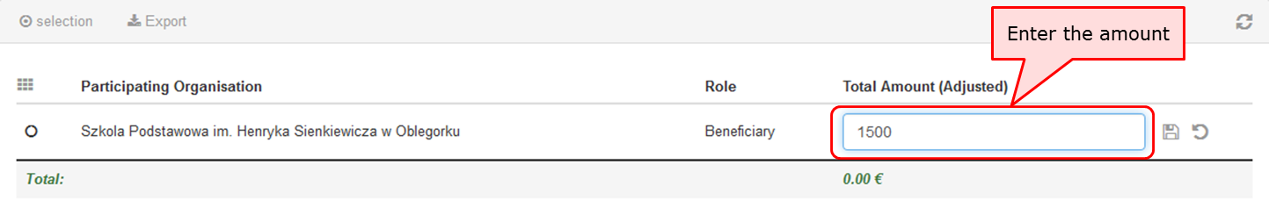

- Click on the save icon.
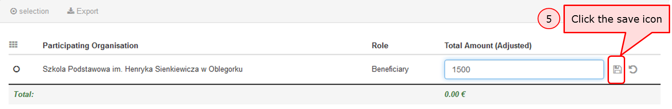
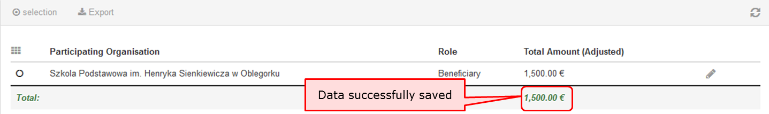

- Add a comment.
Add a comment if the amount is different than the total calculated amount taking into consideration the maximum allowed amount. Click on Save.
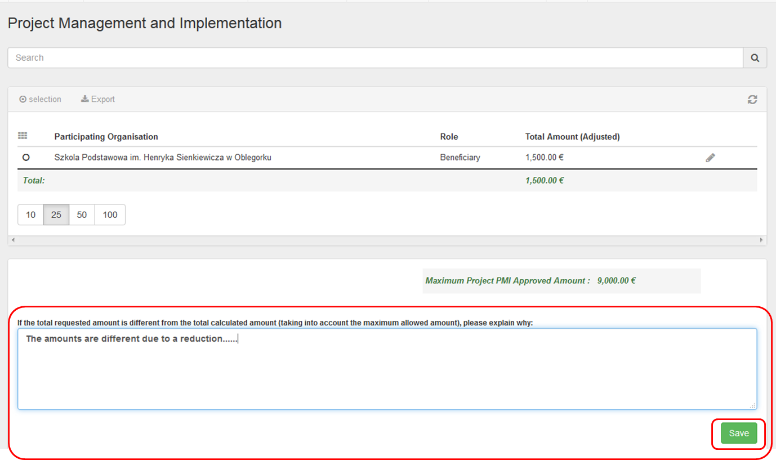

MT+ KA2 Transnational Project Meetings
This page explains how to add the details for a new Transnational Project Meeting. Transnational project meetings are events organised by one of the project's participating organisations with the purpose of project implementation and coordination. The screen functionality allows to list the transnational project meetings, with the number of participants per meeting and its associated cost amounts also per meeting.

Quick steps
- 1. Click on the project reference.
- 2. Open the "Transnational Project Meetings tab".
- 3. Click the "+Create" button.
- 4. Fill in the meeting details.
- 5. To save the details and to add participants, click the "Save" button.
- 6. The participants section appears.
- 7. Click the "+Create" button to add a Participants Form.
- 8. Fill in the details.
- 9. Click the "Save" button.
- 10. The "Participants" list appears.
- 11. Click on "Back to list" to return to the previous screen.
- 12. Click the edit icon.
- 13. Click on delete icon to delete.

Detailed steps
- Click on the project reference.
From the homepage of Mobility Tool click on the project reference to open the project.
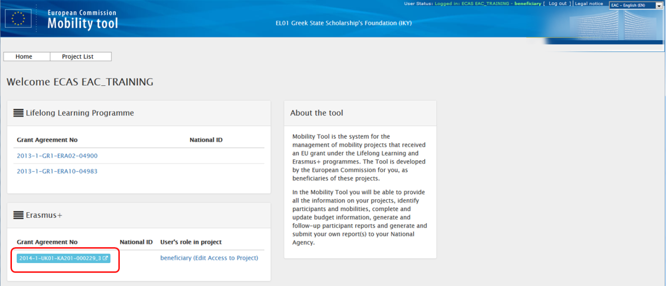

- Open the "Transnational Project Meetings tab".
The Transnational Project Meetings or TPM's entered into National Agency's project management system EPlusLink will not appear in this list, on project creation and will not be updated. The total approved for TPMs can be viewed under the Budget tab.
These entries will have to be added along with the number of attendees and total cost for each meeting. The attendees numbers should be grouped according to the travelling distance or distance band and costs.
If the project is a "KA201 - Strategic partnerships for school education" flagged as "Only schools?" the sending organisation is always the Beneficiary Organisation.
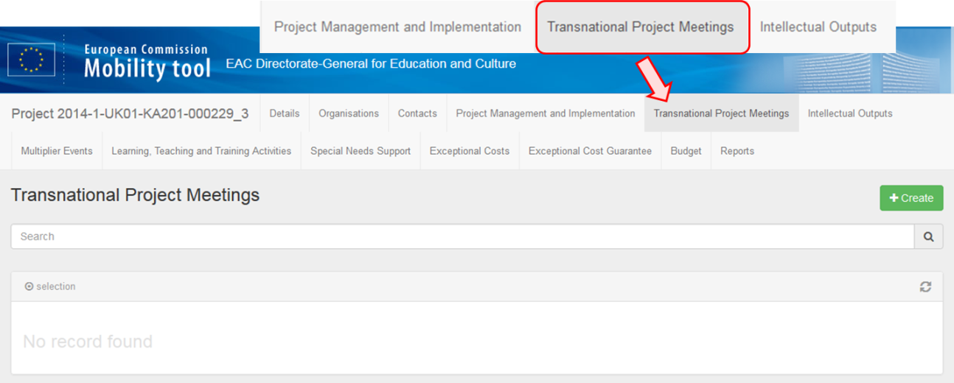

- Click the "+Create" button.
To create a new meeting indicating its specific objectives within the more general purpose of project coordination and implementation, click on the +Create button.
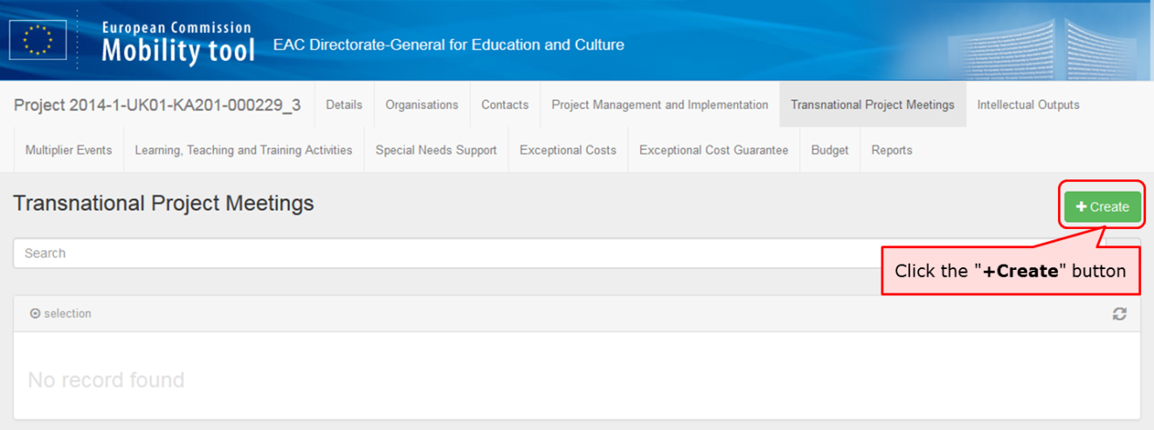

- Fill in the meeting details.
Complete the details (blank fields) as applicable for the meeting.
Add a meeting title, select the receiving organisation (receiving country and receiving city will be filled in automatically) and change the start date and the end date. The meeting must fall between the project start and end date indicated on the Details tab.
For S2S projects the sending organisation can only be the beneficiary organisation.
After filling in all the mandatory fields the "Cancel" and "Save" button will appear.
The receiving organisation cannot be the same as the sending organisation in a given meeting. An exception is made in the following case:
The receiving organisation is allowed to also send their own participants and pay them for travel expenses if the travel distance is at least 100 km (>= 100 km).
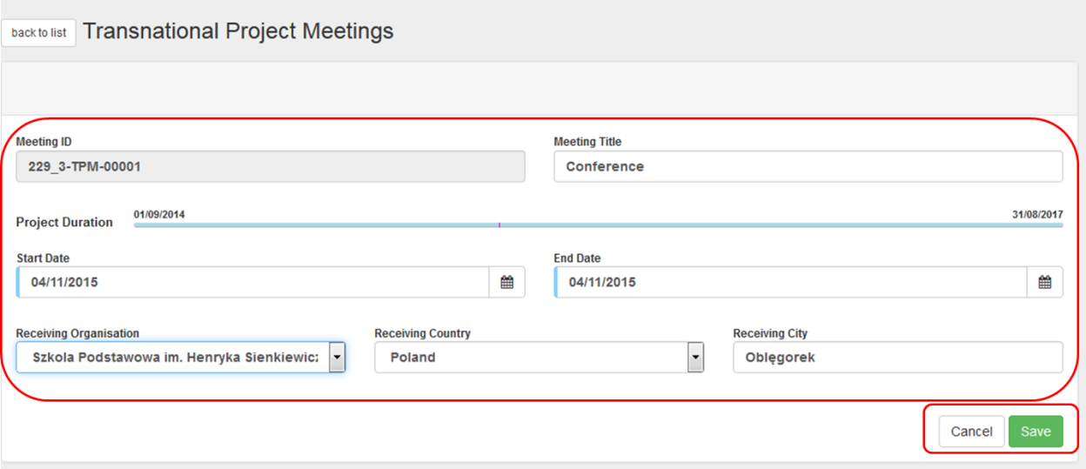

- To save the details and to add participants, click the "Save" button.
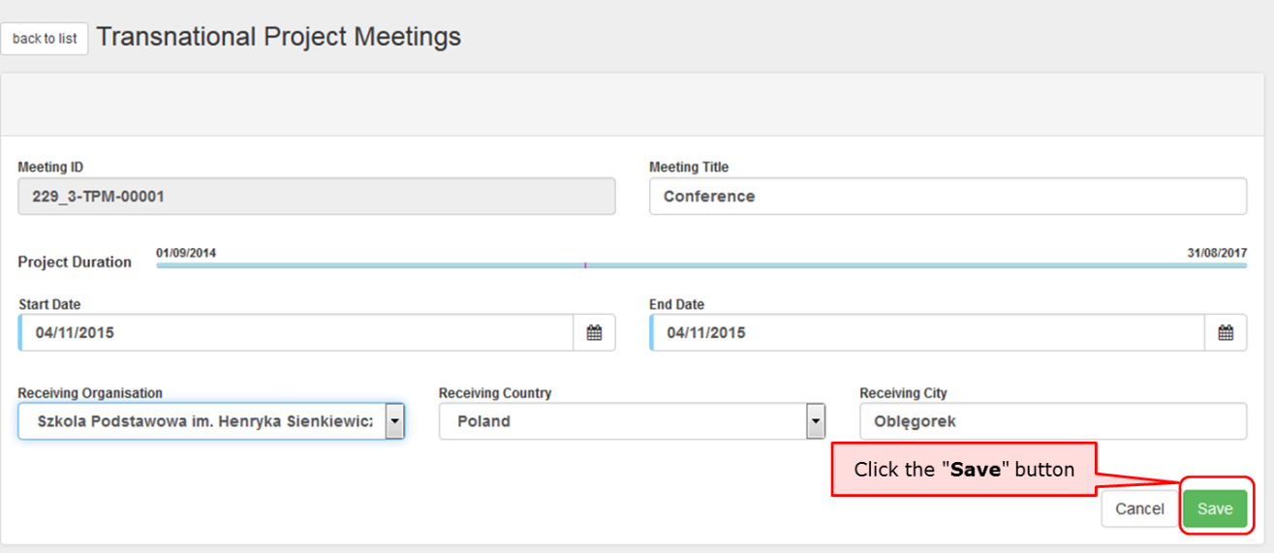

- The participants section appears.
The section "Participants" appears. From this list you can create a new entry for a participant or group of participants. The participants should be grouped according to the distance band.
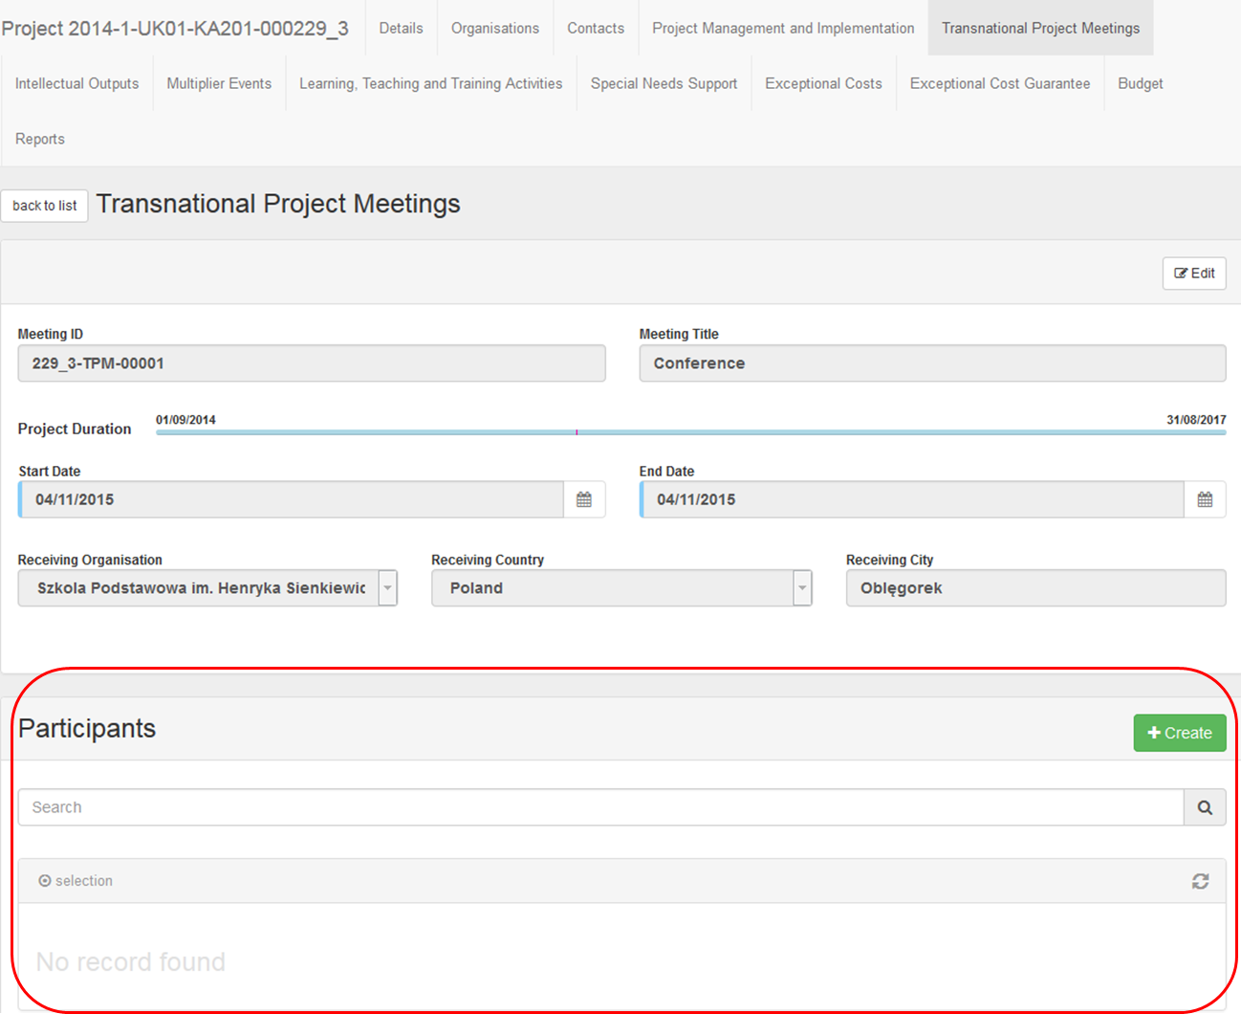

- Click the "+Create" button to add a Participants Form.
To create an attendance list including a clear identification of all attendants for each meeting, click the +Create button.

- Fill in the details.
The fields "Sending Country" and "Sending City" are automatically filled based on the details of the organisation selected in the meeting details.
Fill in the "Distance Band" field. If the distance band is not known, click on the Link to distance calculator.
From the moment the distance band is calculated, the Grant per participant, Total (Calculated) and Total (Adjusted) fields will be automatically filled.

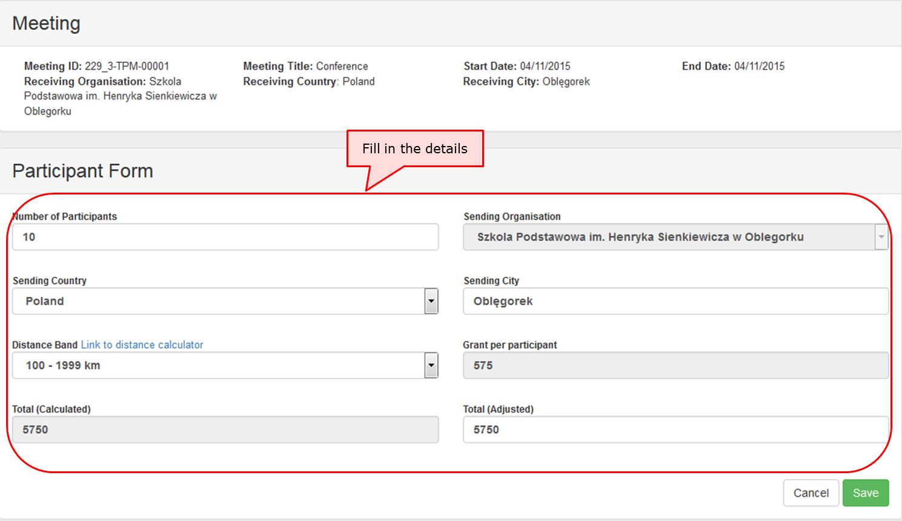

- Click the "Save" button.
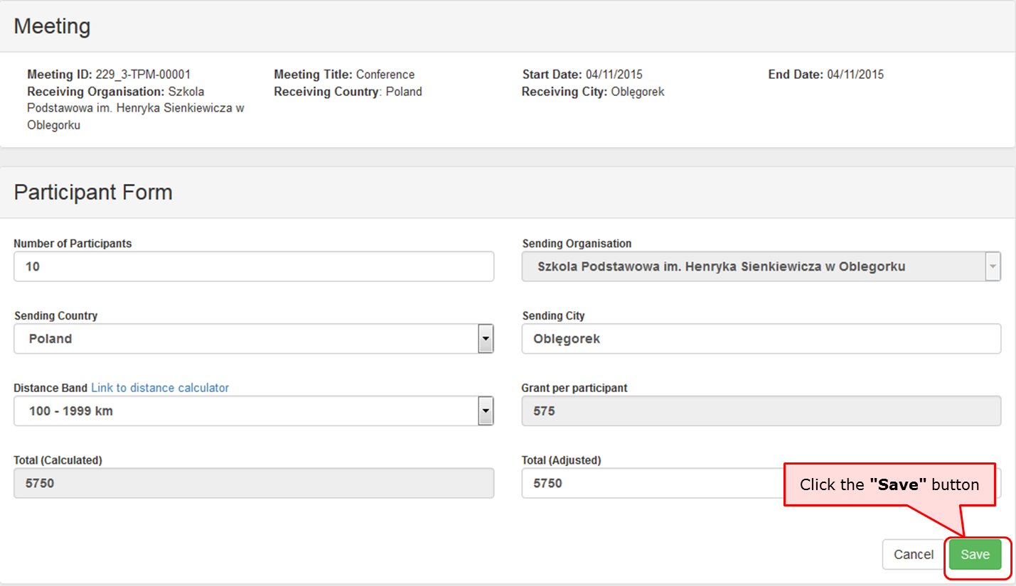
- The "Participants" list appears.
After clicking on save, you are returned to the previous window.
The newly added details appear in a line, in the participants list. Click on the create button to add additional entries for participants if required.
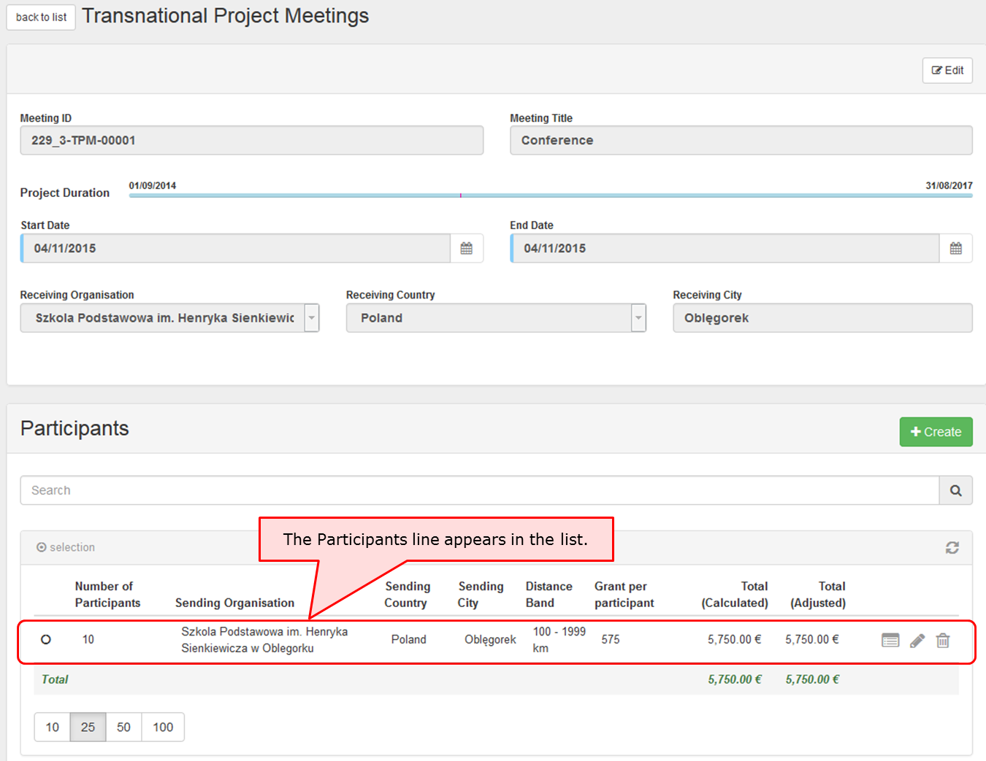
- Click on "Back to list" to return to the previous screen.
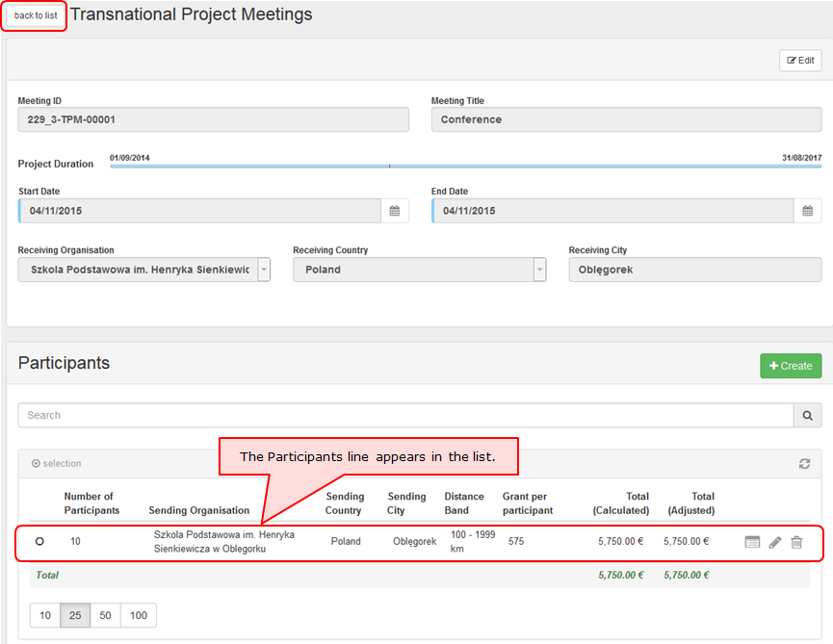

- Click the edit icon.
If you require to make changes click on the pencil icon to edit.
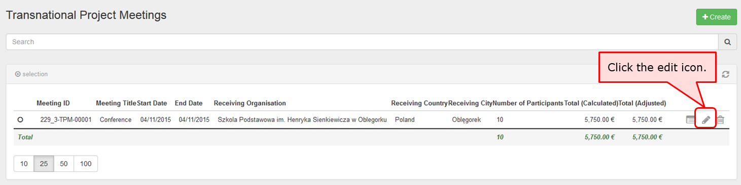

- Click on delete icon to delete.
If you require to remove an entry, click on the dustbin icon to delete it. To view without editing click on the view icon.
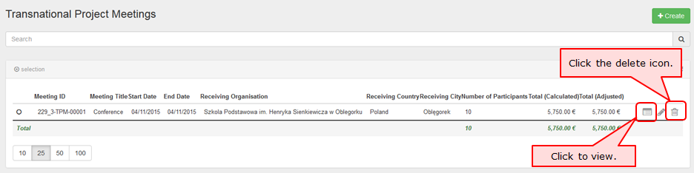

Intellectual Outputs
This page explains how to manage the list of Intellectual Outputs in MT+. Intellectual outputs represent the project's tangible results such as curricula, pedagogical materials, open education resources (OER), IT tools, analyses, studies, methods and others.
The screen allows the beneficiary to list the project's exact set of realised intellectual outputs. It also allows to detail the cost of their production, according to the different types of resources required to produce it.

Quick steps
- 1. Click on the project reference.
- 2. Open the menu item "Intellectual Outputs".
- 3. Edit an Intellectual Output.
- 4. Click "+Create" to add the organisation details.
- 5. Select the organisation and complete the details.
- 6. Click on "Save".
- 7. View the organisation's cost.
- 8. Click on "+Create".
- 9. Complete the details of the new Intellectual Output.
- 10. Click on "Save".
- 11. Delete an Intellectual Output.

Detailed steps
- Click on the project reference.
From the homepage click on the project reference to open the project.
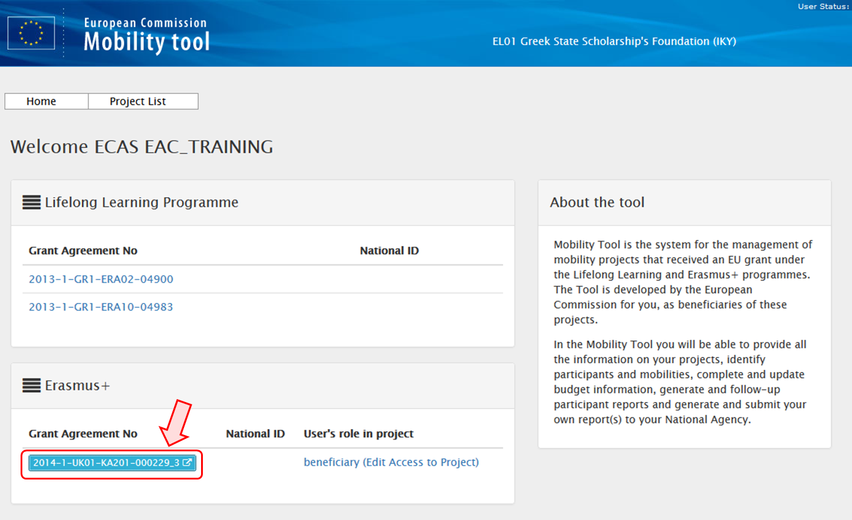

- Open the menu item "Intellectual Outputs".
The list of Intellectual Outputs appears.
The Intellectual Outputs entered into National Agency's project management system EPlusLink will appear in this list. The amount for the different staff categories is not entered and must be added for each Intellectual Output, which is automatically created by the system. The total approved for the Intellectual Outputs is visible under the Budget tab and at the bottom of the screen.
For School to School only the Intellectual Outputs for the beneficiary organisation will appear.
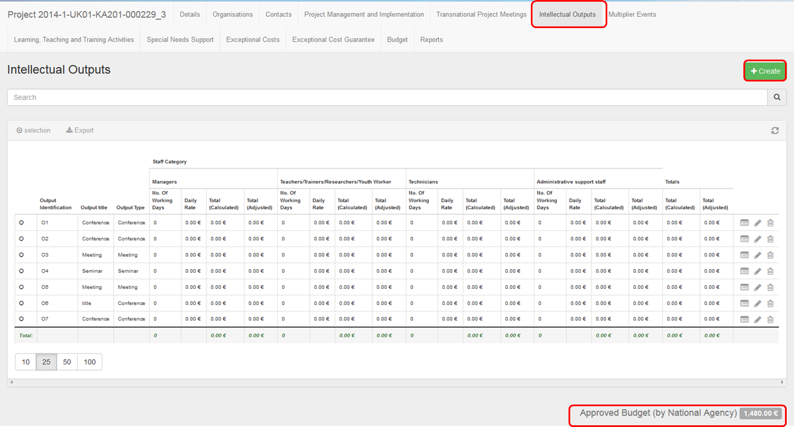
- Edit an Intellectual Output.
To modify an Intellectual Output, click the pencil icon.
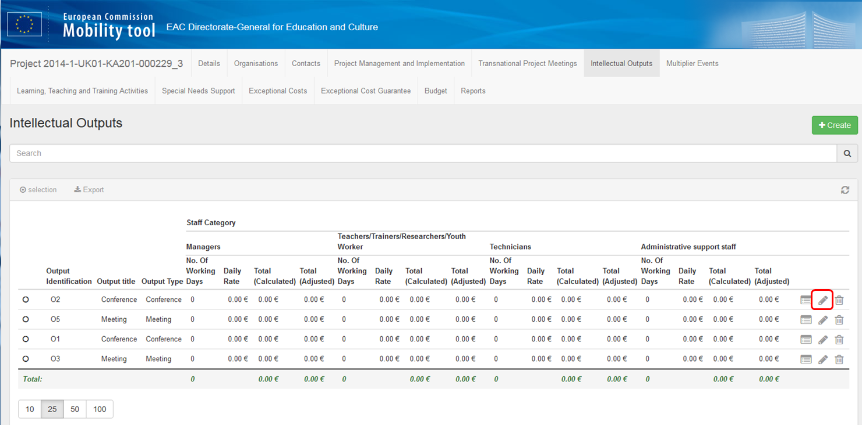

- Click "+Create" to add the organisation details.
The Intellectual Output Details screen appears, completed with the details received from EPlusLink. Click on +Create to add the details of the organisation.
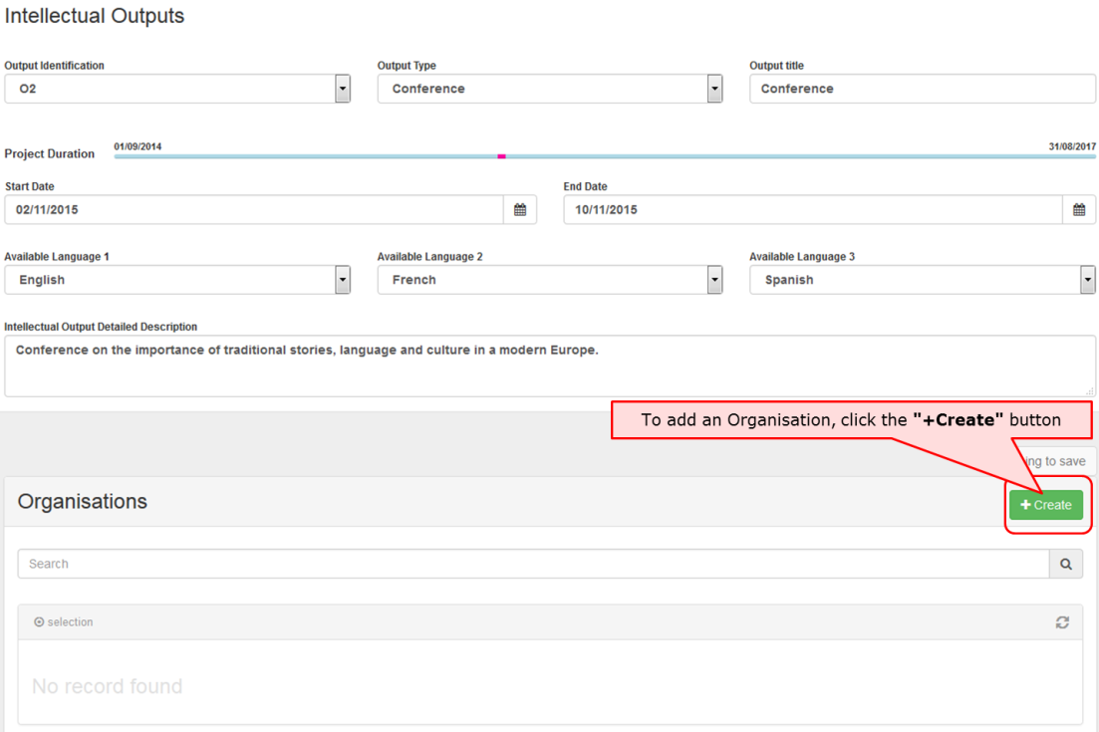
- Select the organisation and complete the details.
Select an organisation and complete the details as applicable for the Intellectual Output.
When filling the fields for No. Of Working Days, both Total (Calculated) and Total (Adjusted) fields will be filled in automatically for each resource type.
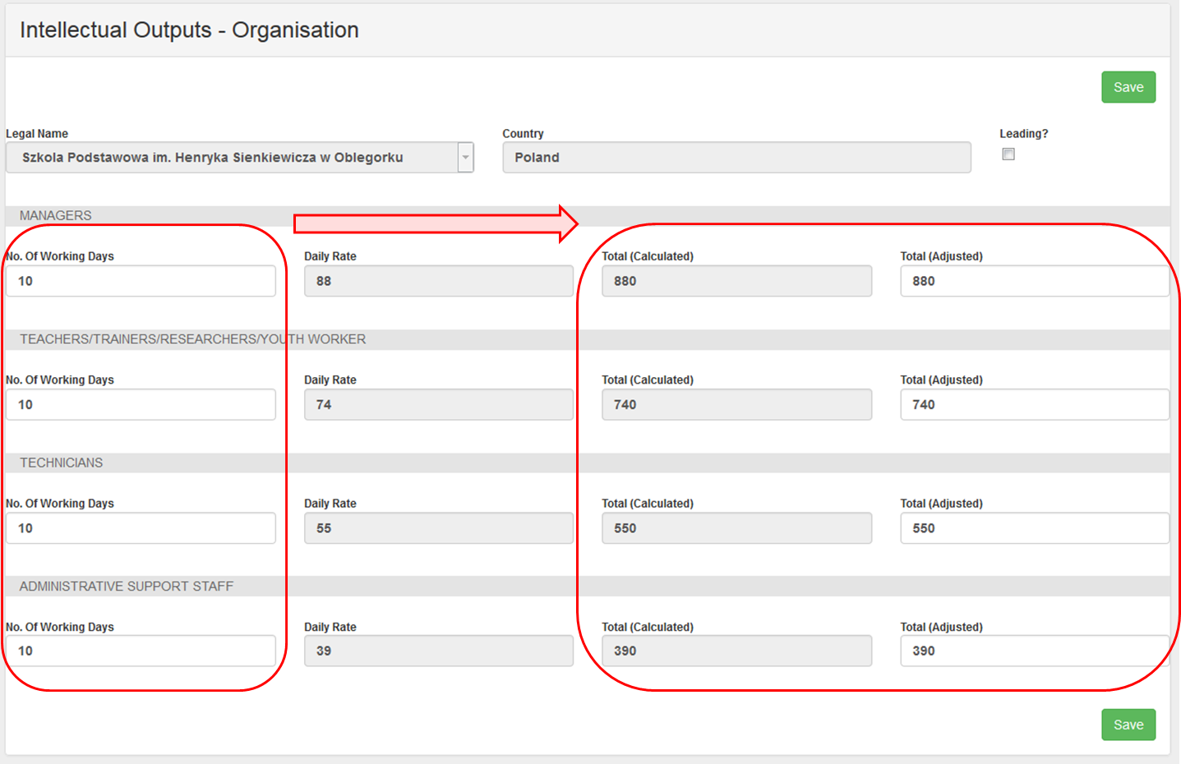

- Click on "Save".
Click on the Save button to save the data and return to the list view of the current Intellectual Outputs.
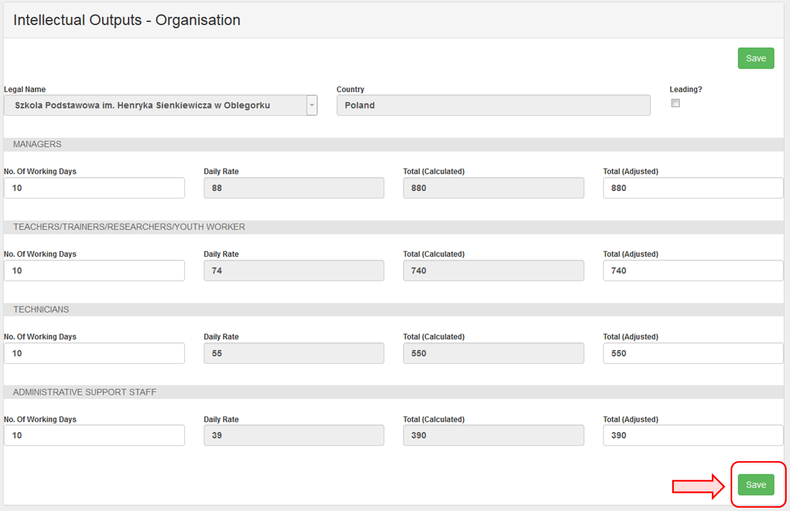
- View the organisation's cost
After clicking on Save, the current Intellectual Output screen appears. The organisation's cost just entered for that intellectual output will be displayed at the bottom of the screen. For School to School it will only be possible to add one line for the beneficiary organisation. To return to the list of all Intellectual Outputs, click on back to list.
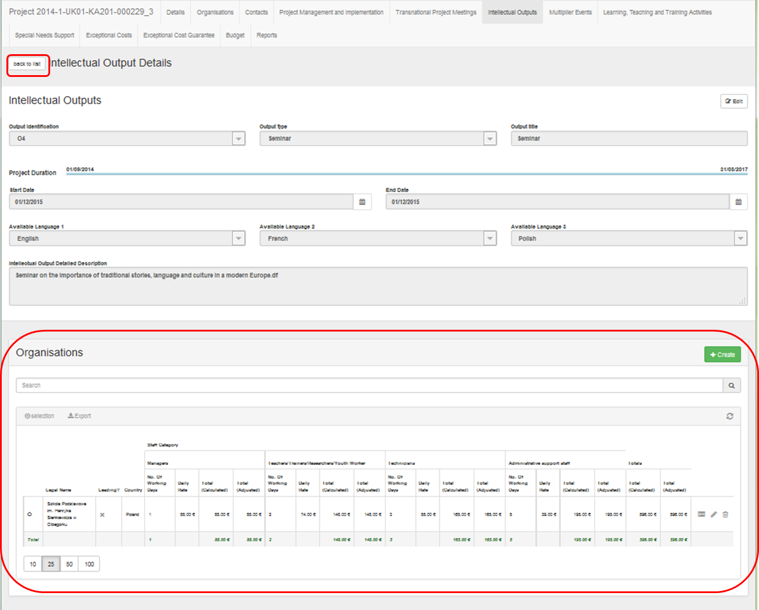

- Click on "+Create".
If a new Intellectual Output is required, click on the +Create button.
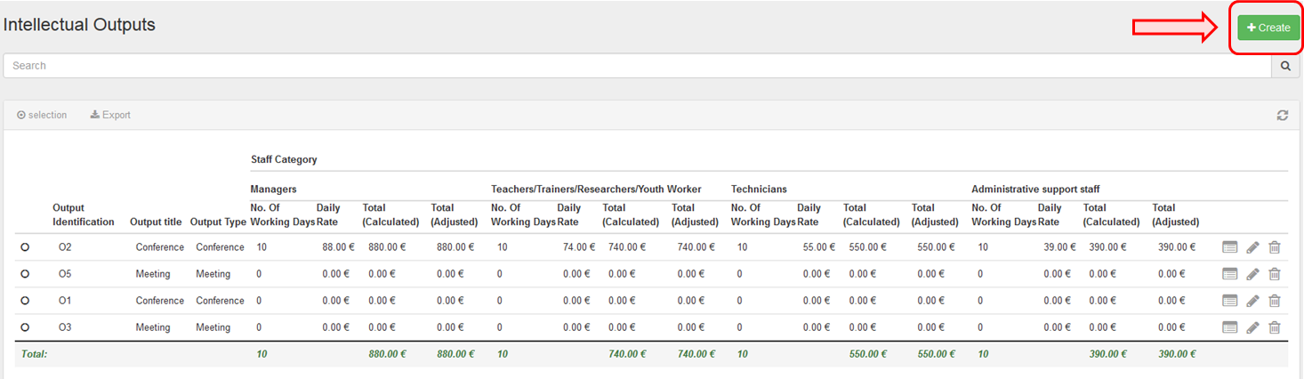

- Complete the details of the new Intellectual Output.
Fill in the blank fields.
Note that the start and end dates for Intellectual Outputs must always be within the project duration (including start and end dates) as specified on the Details tab.
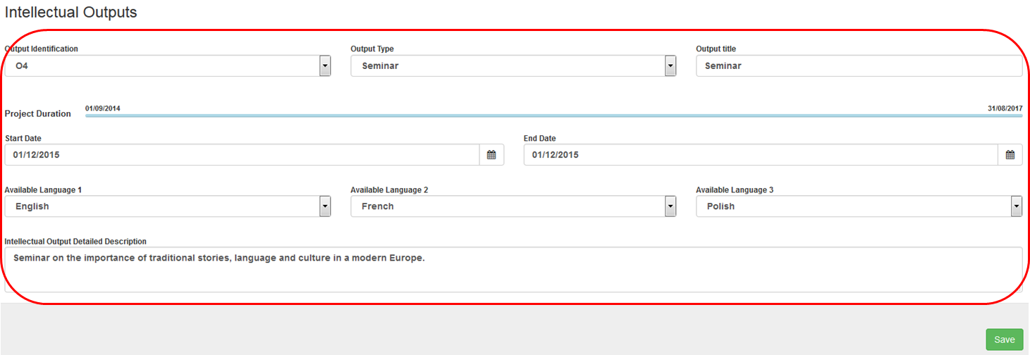

- Click on "Save".
To save the information, click the Save button.
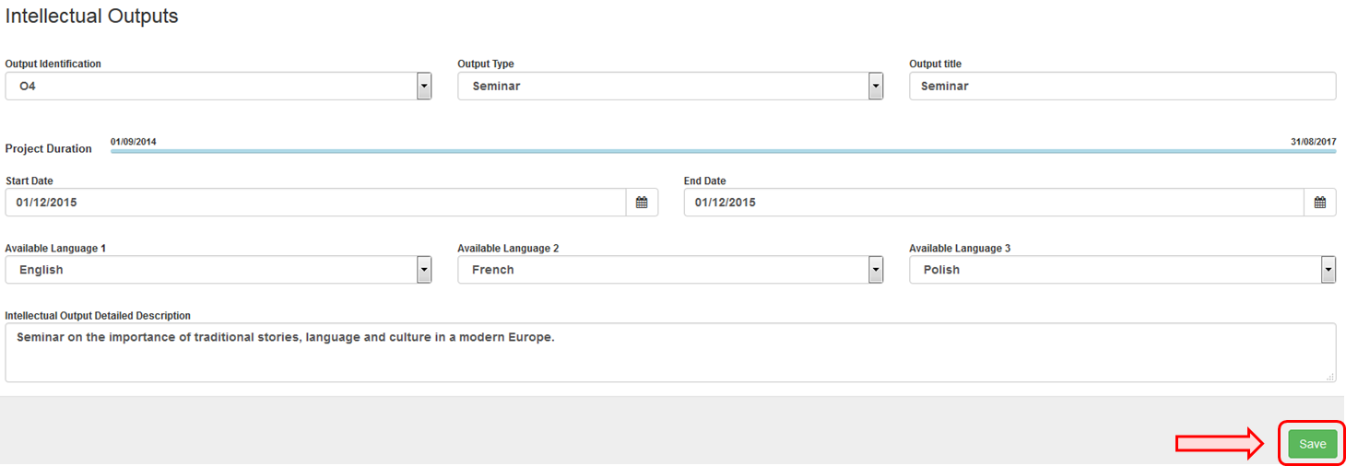

- Delete an Intellectual Output.
To delete an Intellectual Output, click the bin icon.

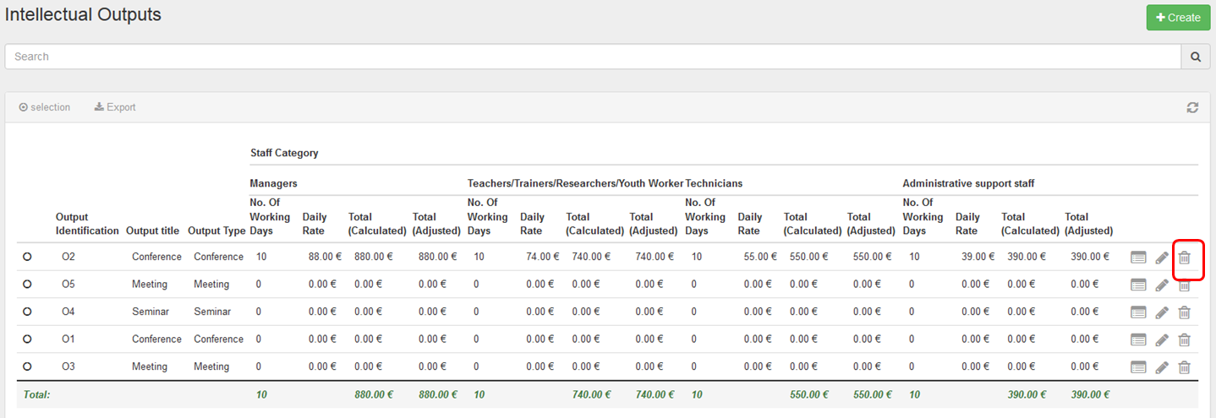

Multiplier Events
This page explains how to manage the list of Multiplier Events in MT+.
Multiplier Events are national and transnational conferences, seminars and other events organised with the purpose of disseminating the intellectual outputs produced by the project. The costs incurred in the organisation of such multiplier events can be financially supported.

Quick steps
- 1. Click on the project reference.
- 2. Click on the menu item "Multiplier Events".
- 3. Click the "+Create" button.
- 4. Fill in the details.
- 5. Click on "Save".
- 6. Edit a "Multiplier Event".
- 7. Delete a "Multiplier Event".

Detailed steps
- Click on the project reference.
In the homepage click on the project reference in order to open the project.
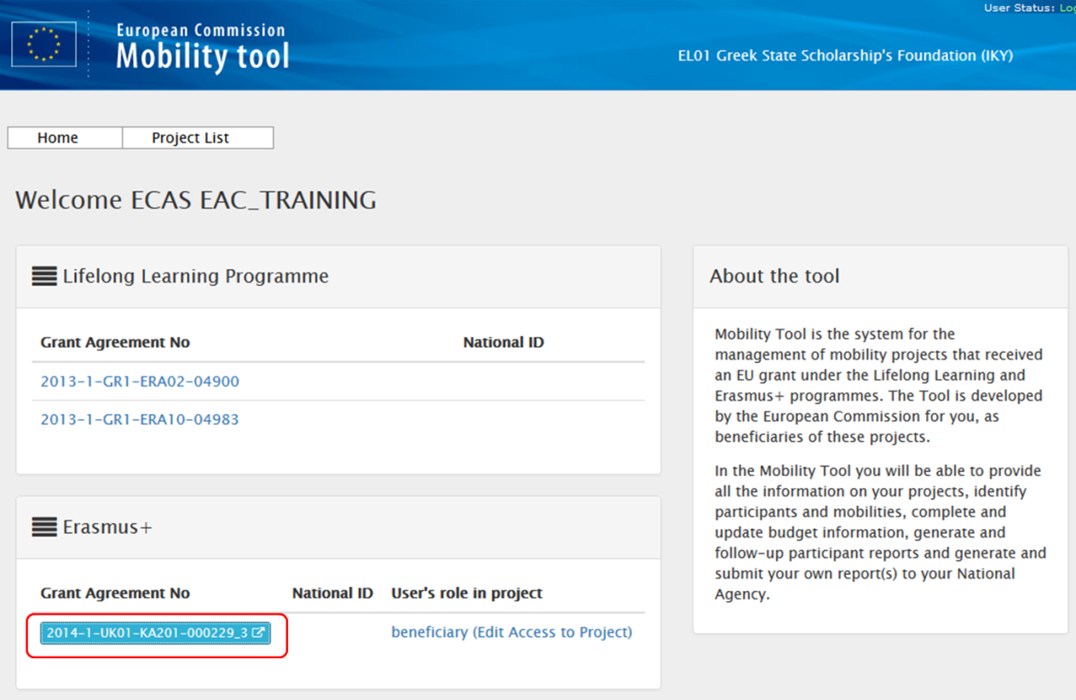

- Click on the menu item "Multiplier Events".
The list of Multiplier Events is displayed. The items in the list can be edited and new ones can be added.
The list will show all Multiplier Events, which have been entered into EPlusLink but will not contain all details. The Multiplier Event item must be edited in order to add the costs and number of participants.
Note, that the amount can not exceed 120% or be less than 80% of the approved amount. This range is indicated in the Budget tab along with the total of the approved amount for the Multiplier Events.
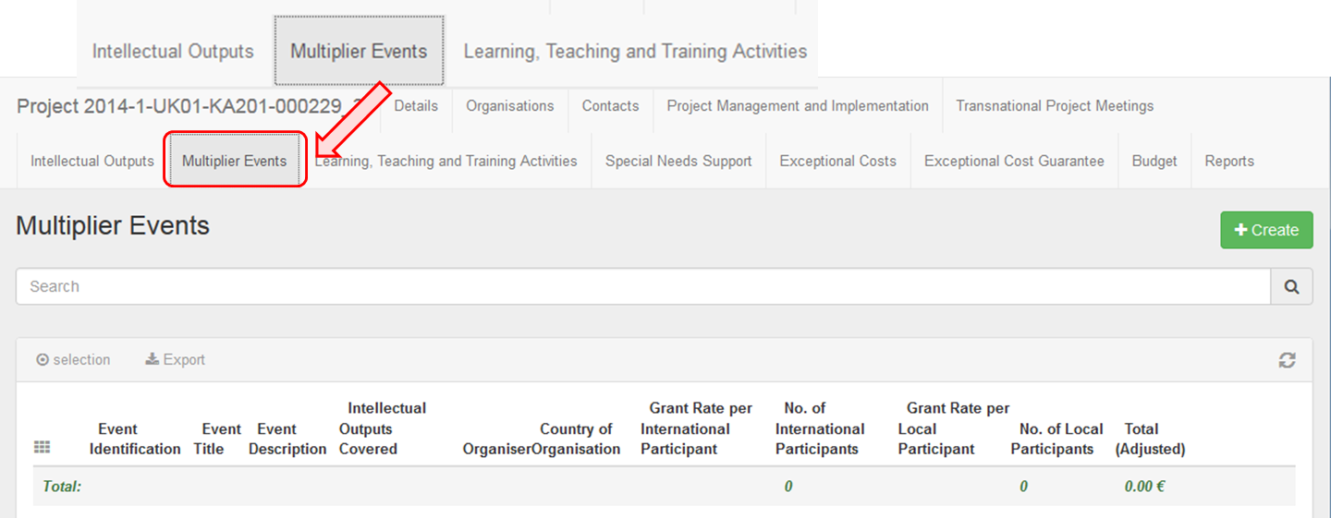

- Click the "+Create" button.
In order to create a new Multiplier Event, click the +Create button.
For school-to-school projects, only the Multiplier Events for the beneficiary organisation can be created.
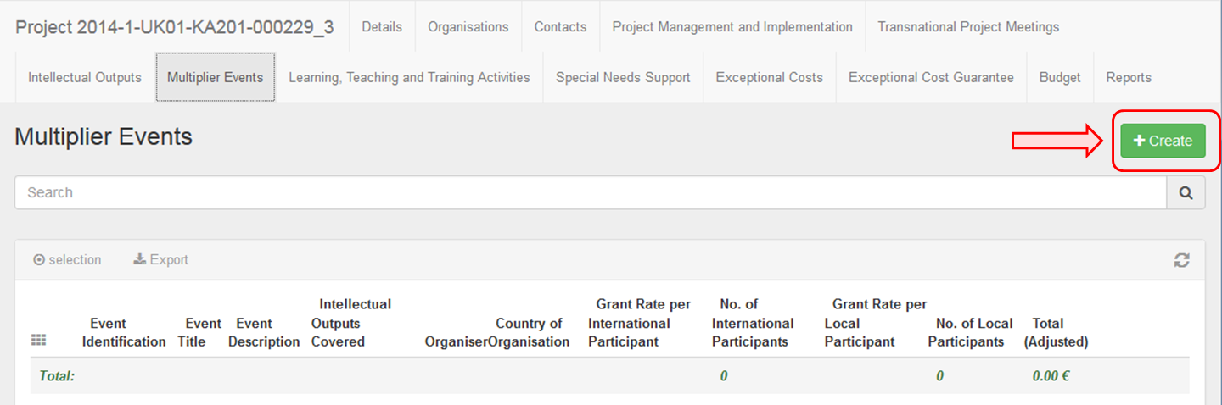

- Fill in the details.
Complete the details as applicable for the event.
For Multiplier Events, which are not automatically created from EPlusLink, select predefined Event Identification codes ranging from E1 to E999 from the drop-down list.
Note that the maximum allowed amount for all Multiplier Events within a project can not exceed 30.000€.
The start and end dates for an event must always be within the project duration as specified in the project Details tab. In case there is a need to change these dates, it should be done in EPlusLink.
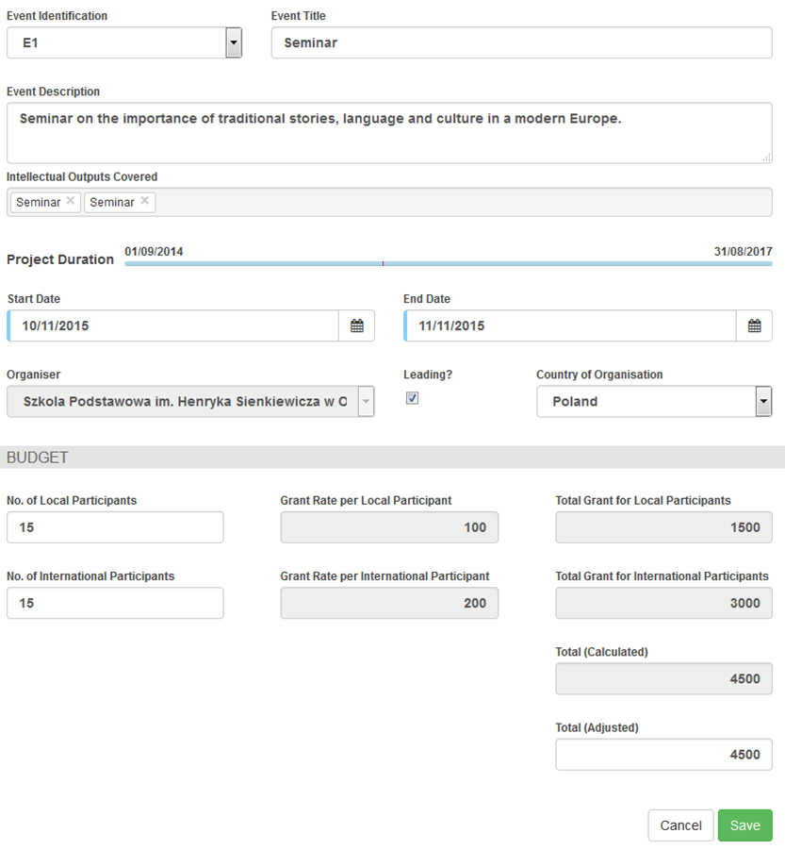
- Click on "Save".
To save the data, click the Save button.
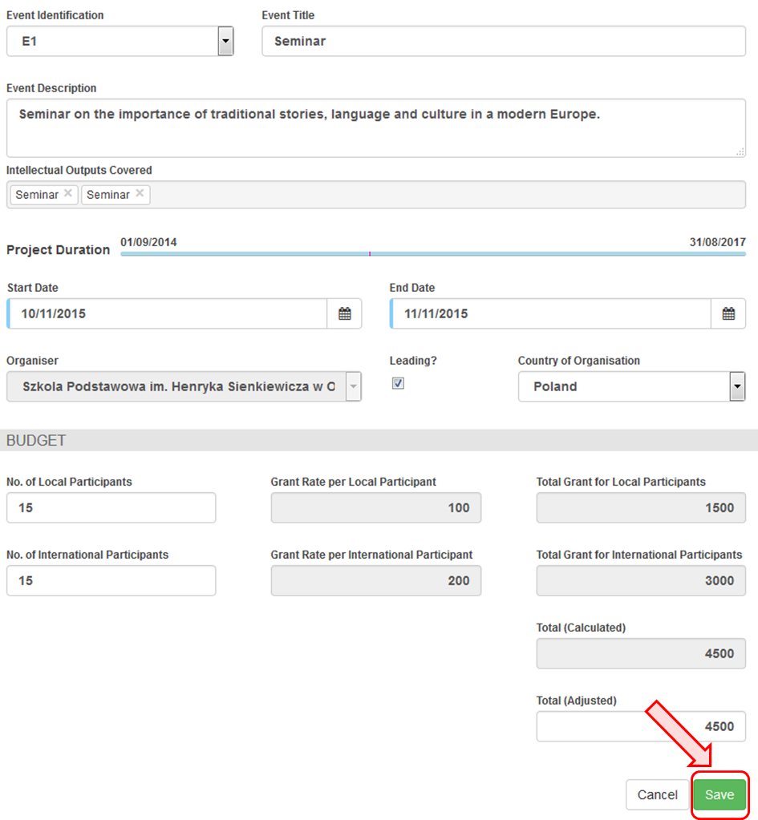

- Edit a "Multiplier Event".
To edit an event, click the pencil icon.
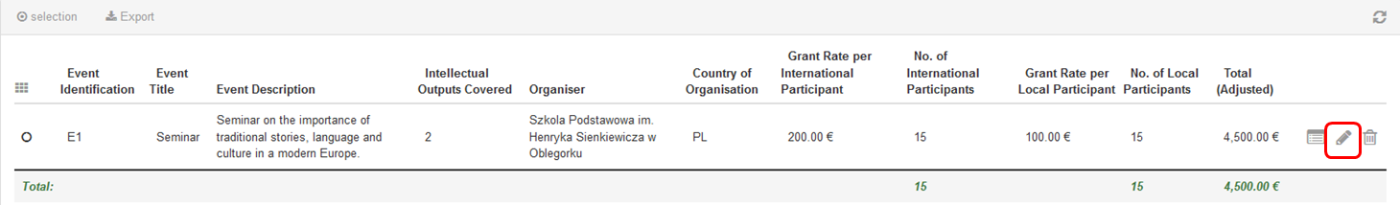

- Delete a "Multiplier Event".
To delete an event, click on the bin icon.
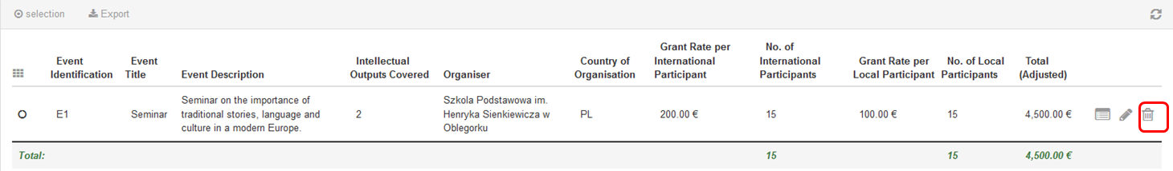

Learning, Teaching and Training Activities
This page explains how to manage the list of Learning, Teaching and Training Activities in MT+.
A strategic partnerships' project can optionally include transnational learning, teaching and training activities for which support for travel, subsistence and linguistic preparation can be given. These activities must be justified by the added value that they bring to the project's achievements.

Quick steps
- 1. Click on the project reference.
- 2. Open the menu item "Learning, Teaching and Training Activities".
- 3. Click the "+Create" button.
- 4. Fill in the details.
- 5. Click on "Save".
- 6. Add a participant.
- 7. Fill in the "Participant" details.
- 8. Use the "compact view" button if necessary.
- 9. Click on "Save".
- 10. Click on "back to list".

Detailed steps
- Click on the project reference.
In the homepage click on the project reference in order to open the project. It will open in a new browser tab.
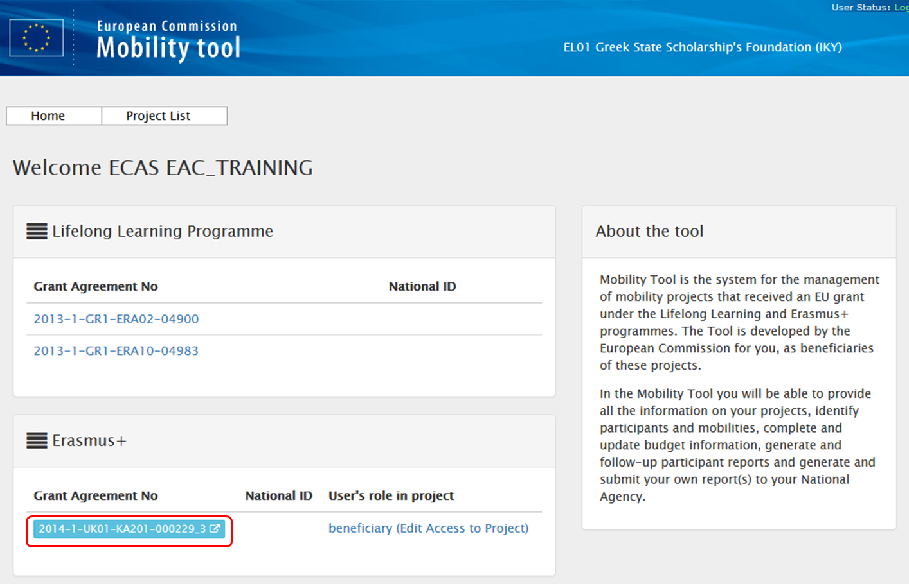

- Open the menu item "Learning, Teaching and Training Activities".
The list of Learning, Teaching and Training Activities or LTT is displayed. The list will show all LTTs, which have been entered into EPlusLink. These items will need to be edited in order to add the additional information of number of participants and costs.
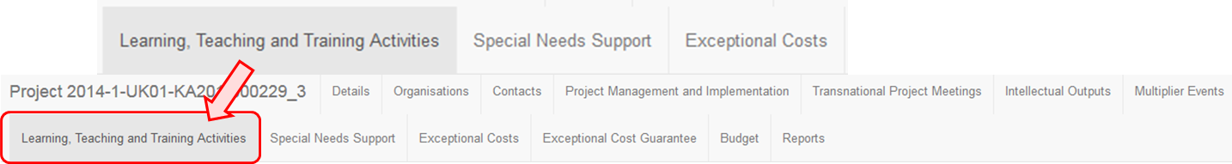

- Click the "+Create" button.
In order to create a new Learning Teaching and Training Activity, click on the +Create button.
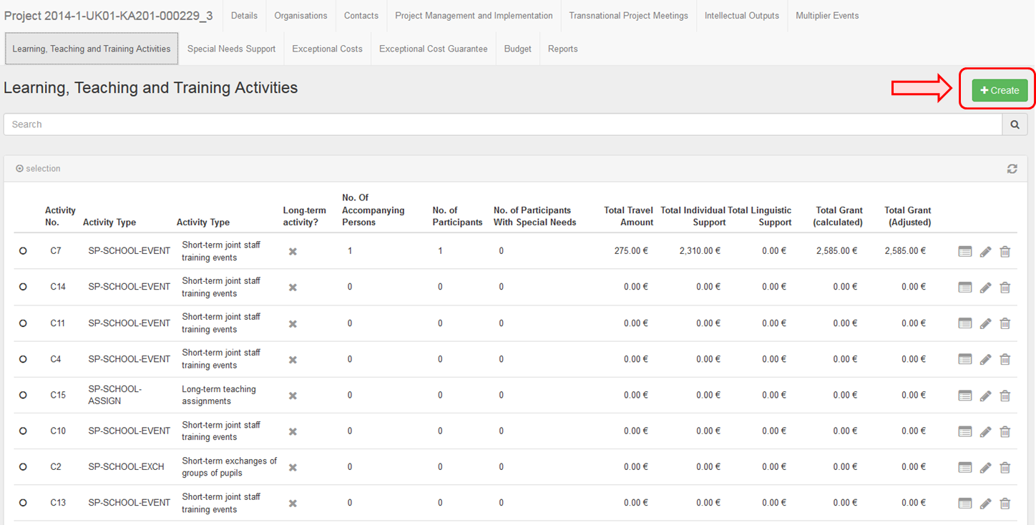

- Fill in the details.
The activity section will appear. Note that the list of participants can be added only after the activity section is completed. Fill in the activity details (blank fields) as applicable.
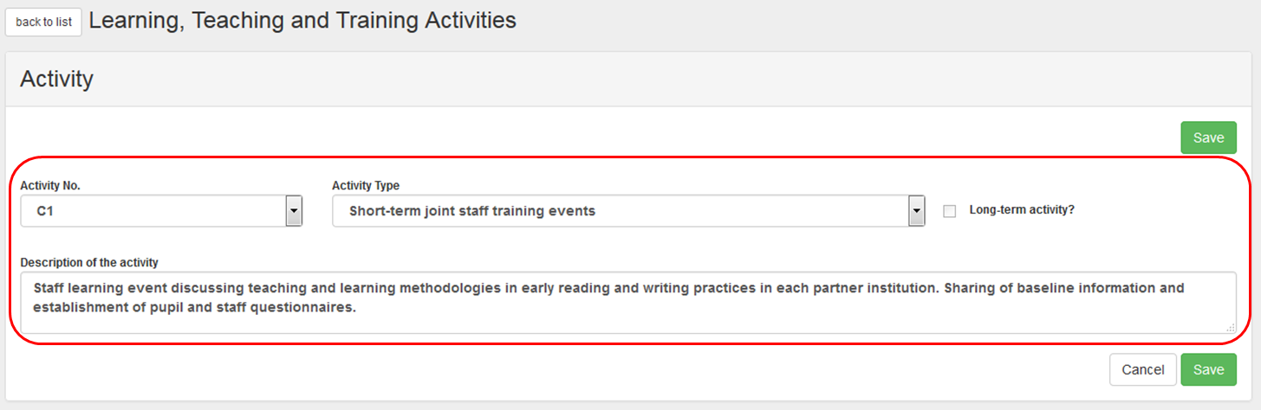

- Click on "Save".
To save the details of the activity, click the Save button. The list of participants can now be added.
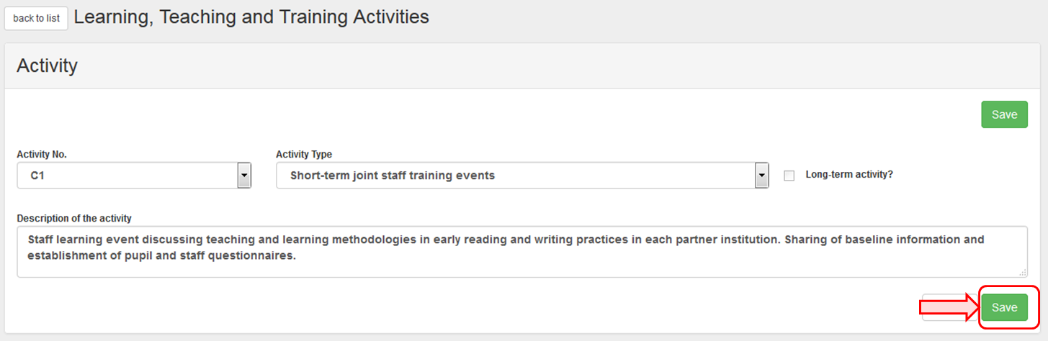

- Add a participant.
To add a participant, click the +Create button in the Participants section.
In case the project is a KA201 - Strategic Partnerships for school education and is flagged as Only schools, the sending organisation is always the Beneficiary Organisation.
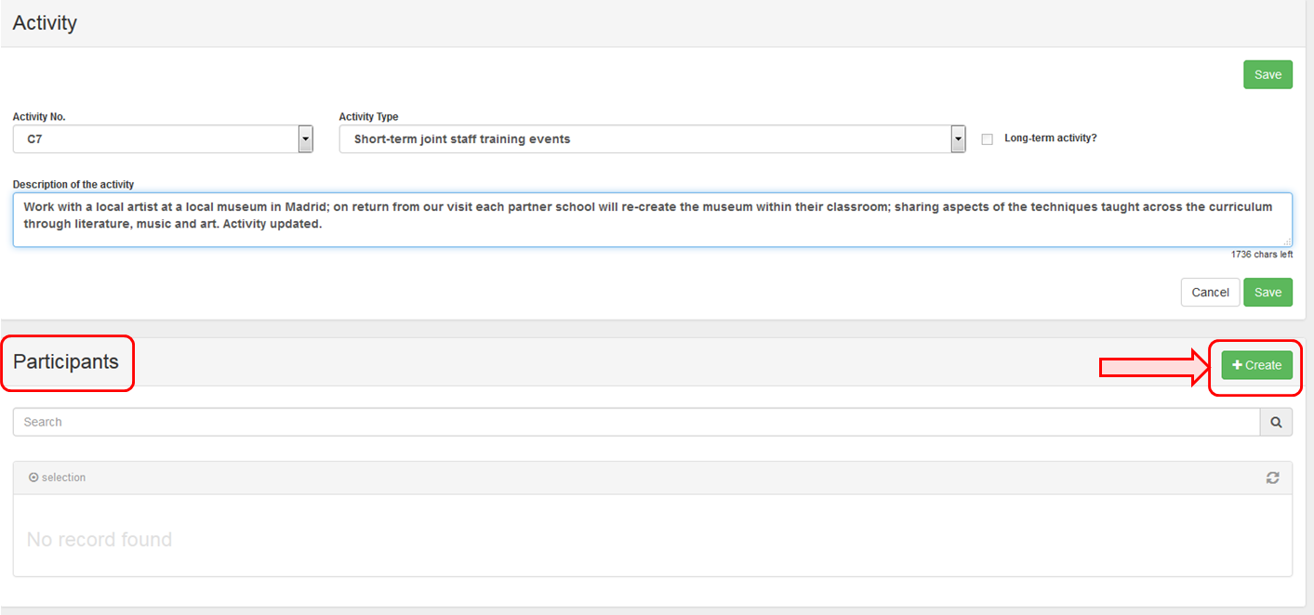

- Fill in the "Participant" details.
Complete the details (blank fields) as applicable for the participants.
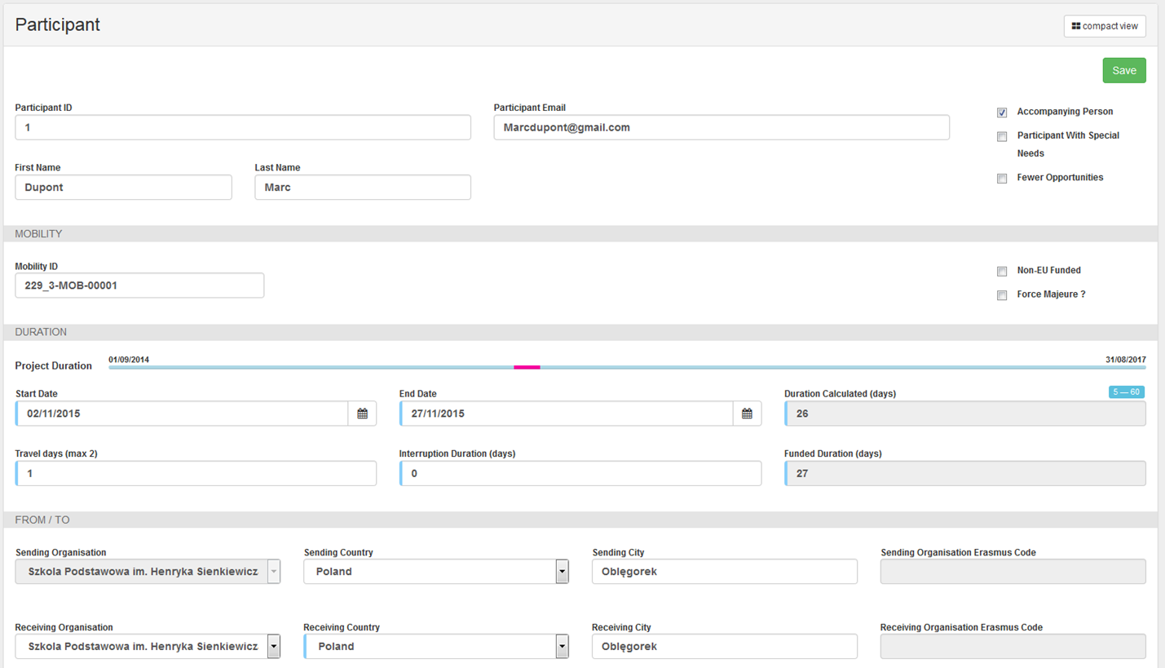

- Use the "compact view" button if necessary.
If necessary, use the compact view button. This will reduce the screen view so that only the most relevant and mandatory fields are displayed. In order to expand the view, click again.
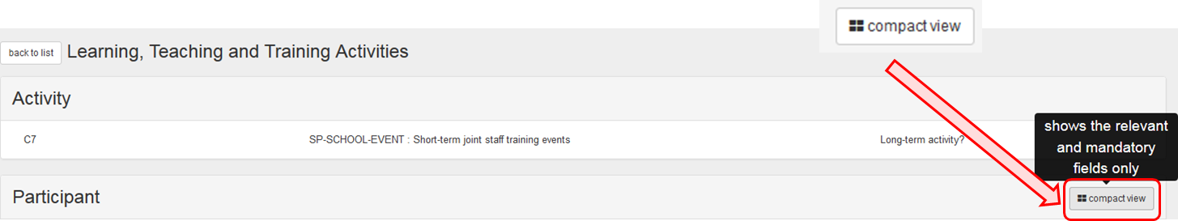
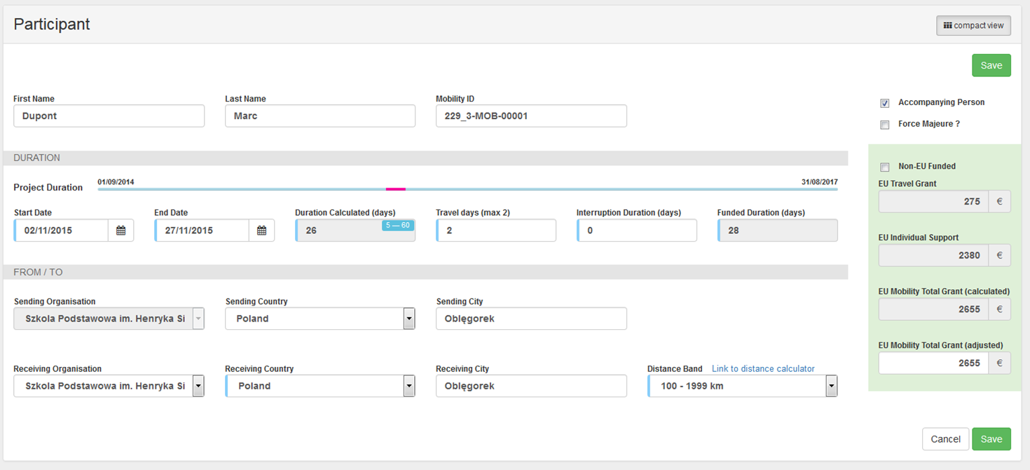

- Click on "Save".
To save the participant details for the activity, click on the Save button.
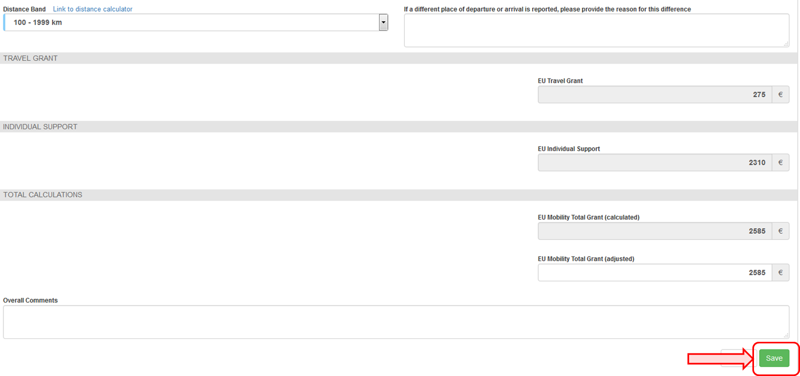

- Click on "back to list".
After clicking on Save, the details of the participant will appear in the Participants list. Use the list icons in order to edit or delete the details.
To return to the list view of all Learning, Teaching and Training Activities, click on back to list.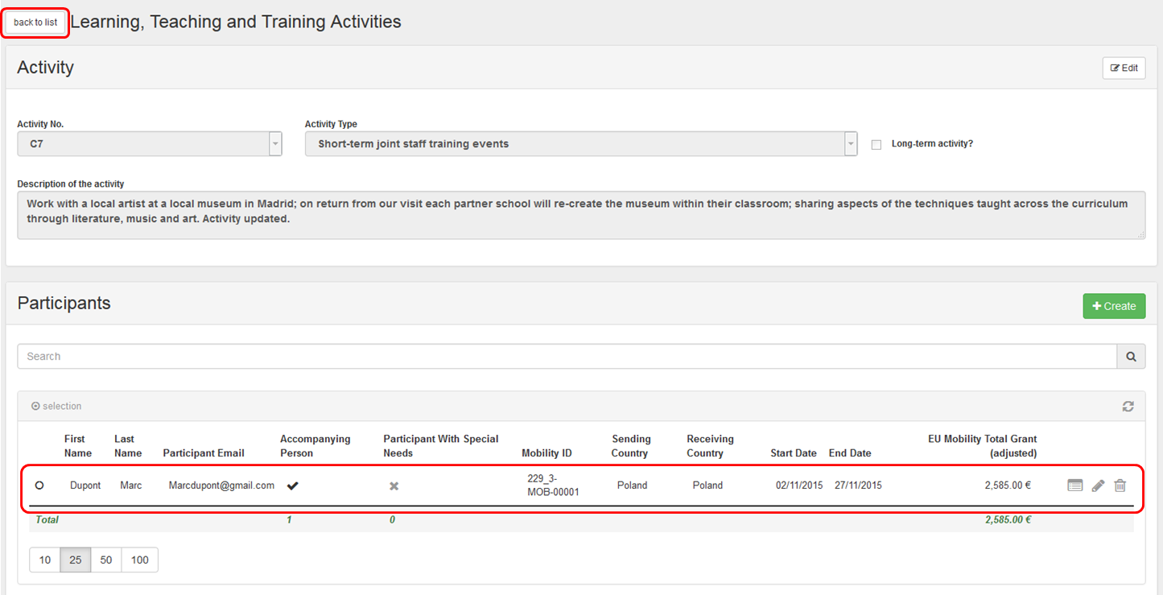

Special Needs Support
Participants with special needs are entitled to extra financial support within the scope of a strategic partnerships project.

Quick steps
- 1. Click on the project reference number.
- 2. Click the menu item "Special Needs Support".
- 3. Click the "+Create" button.
- 4. The "Special Needs Details" window appears.
- 5. Fill in the "Special Needs Details".
- 6. Click on "Save".
- 7. Edit "Special Needs Support".
- 8. Delete "Special Needs Support".

Detailed steps
- Click on the project reference number.
In the homepage click on the project reference in order to open the project. It will open in a new browser tab.
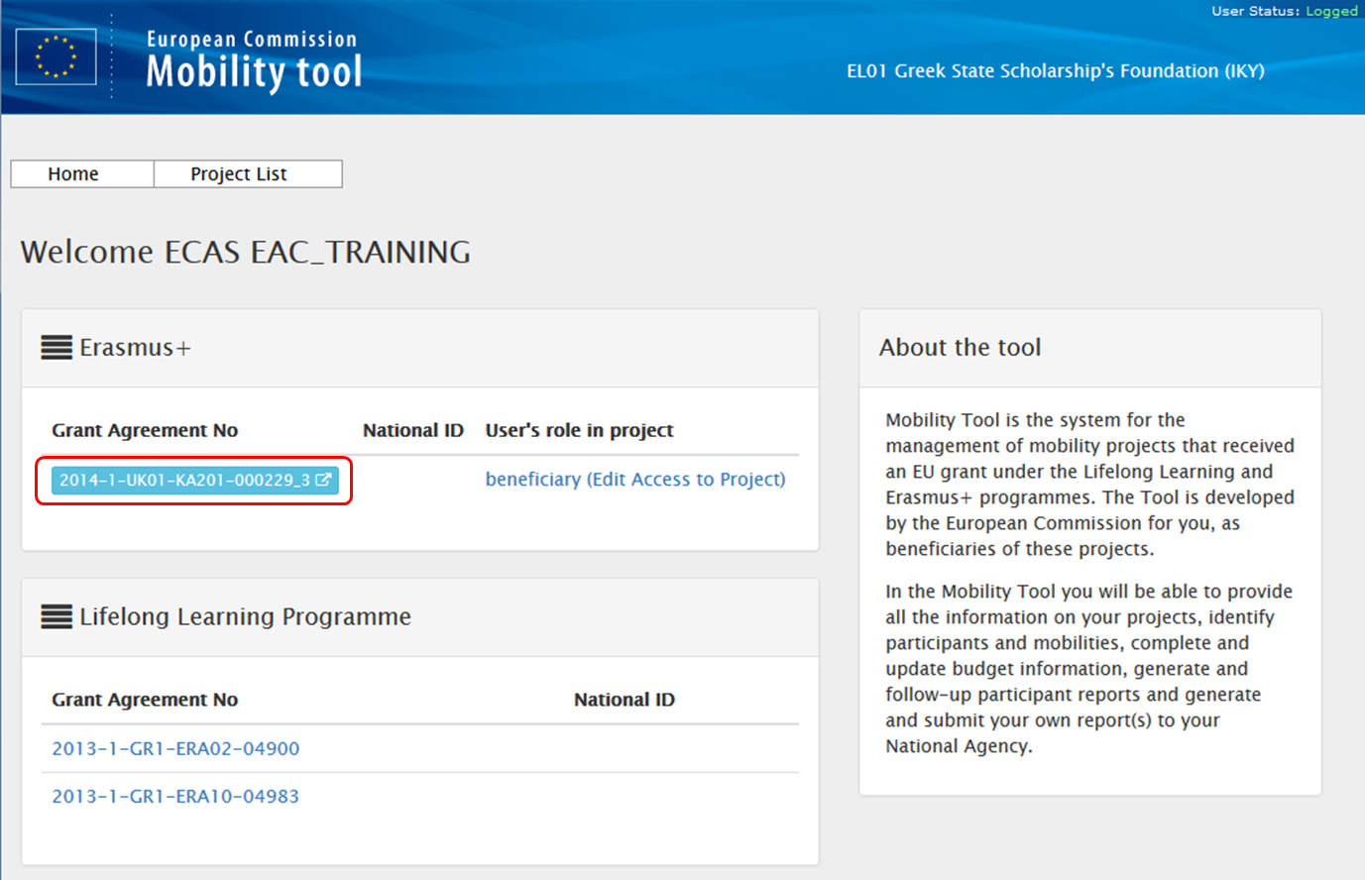

- Click the menu item "Special Needs Support".
The list of Special Needs Support appears. The list will show all Special Needs Support items, which have been entered into EPlusLink.
These entries can be edited in order to add additional information.
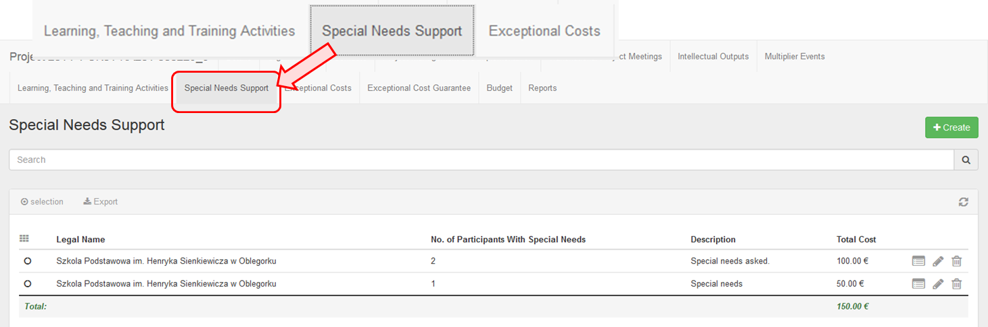

- Click the "+Create" button.
In order to add a cost line for Special Needs Support, click the +Create button.

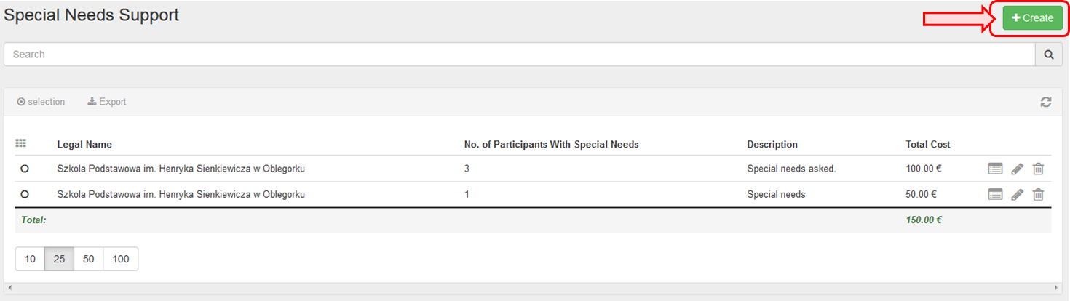
- The "Special Needs Details" window appears.
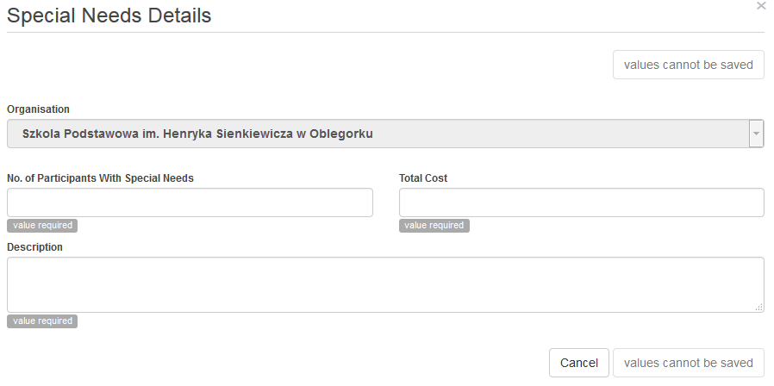

- Fill in the "Special Needs Details".
Fill in the details (blank fields) as applicable.

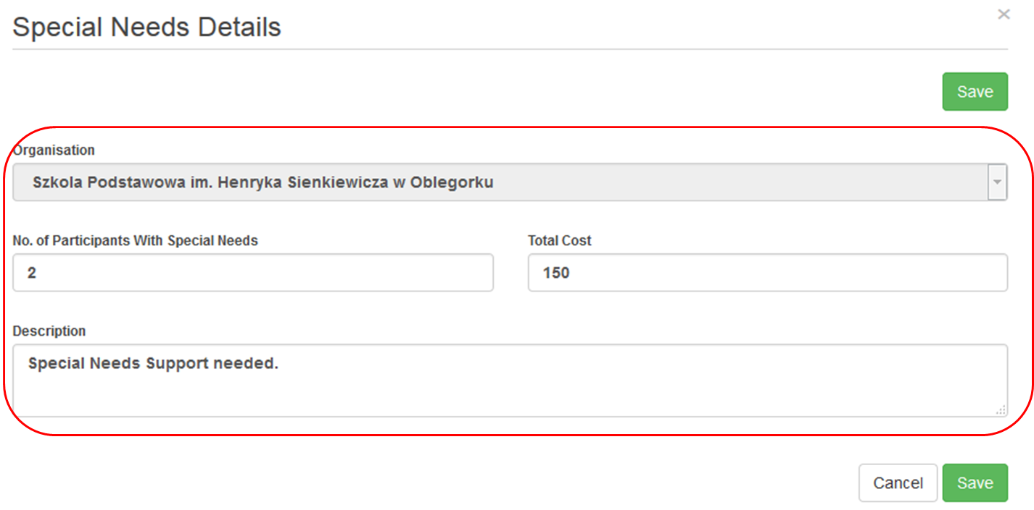
- Click on "Save".
To save the data, click the Save button. After clicking on save, the details line will now appear in the list of Special Needs Support.
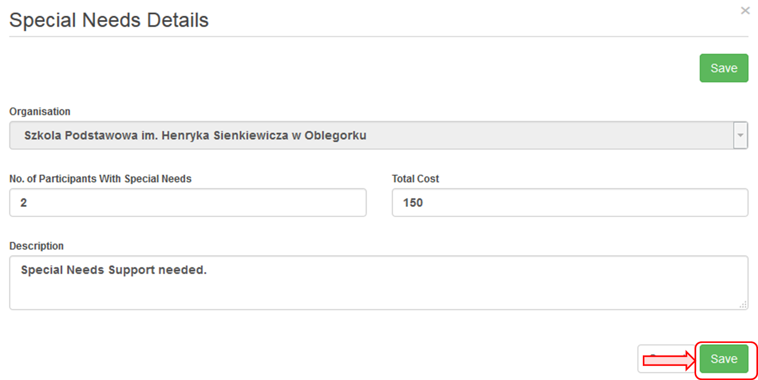

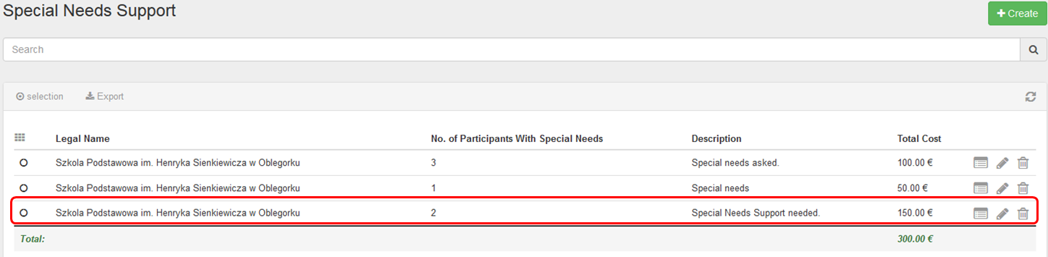

- Edit "Special Needs Support".
To edit a line of Special Needs Support, click the pencil icon, update the data and click on Save.
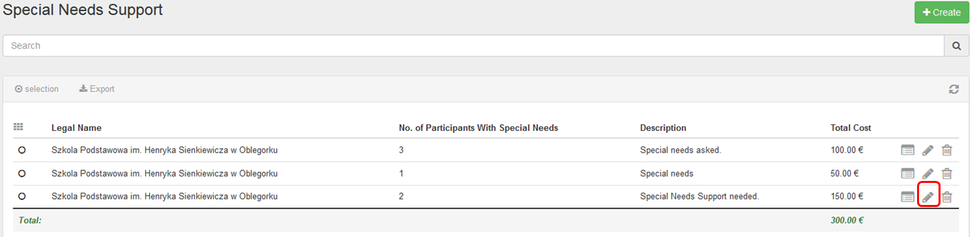

- Delete "Special Needs Support".
To delete a line of Special Needs Support, click the bin icon.
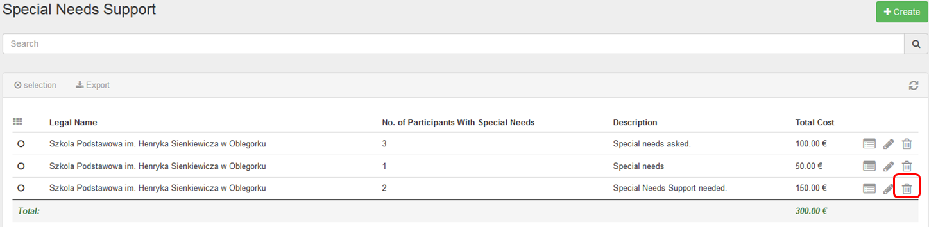

Exceptional Costs
This page explains how to manage the "Exceptional Costs" in MT+.
Exceptional costs include but are not limited to sub-contracting and purchase of goods/services. If exceptional costs are added, a comment must be entered on the budget screen.

Quick steps
- 1. Click on the project reference.
- 2. Click the menu item "Exceptional Costs".
- 3. Click the "+Create" button.
- 4. Fill in the details.
- 5. Click on "Save".
- 6. Add a comment

Detailed steps
- Click on the project reference.
In the homepage click on the project reference in order to open the project. It will open in a new browser tab.
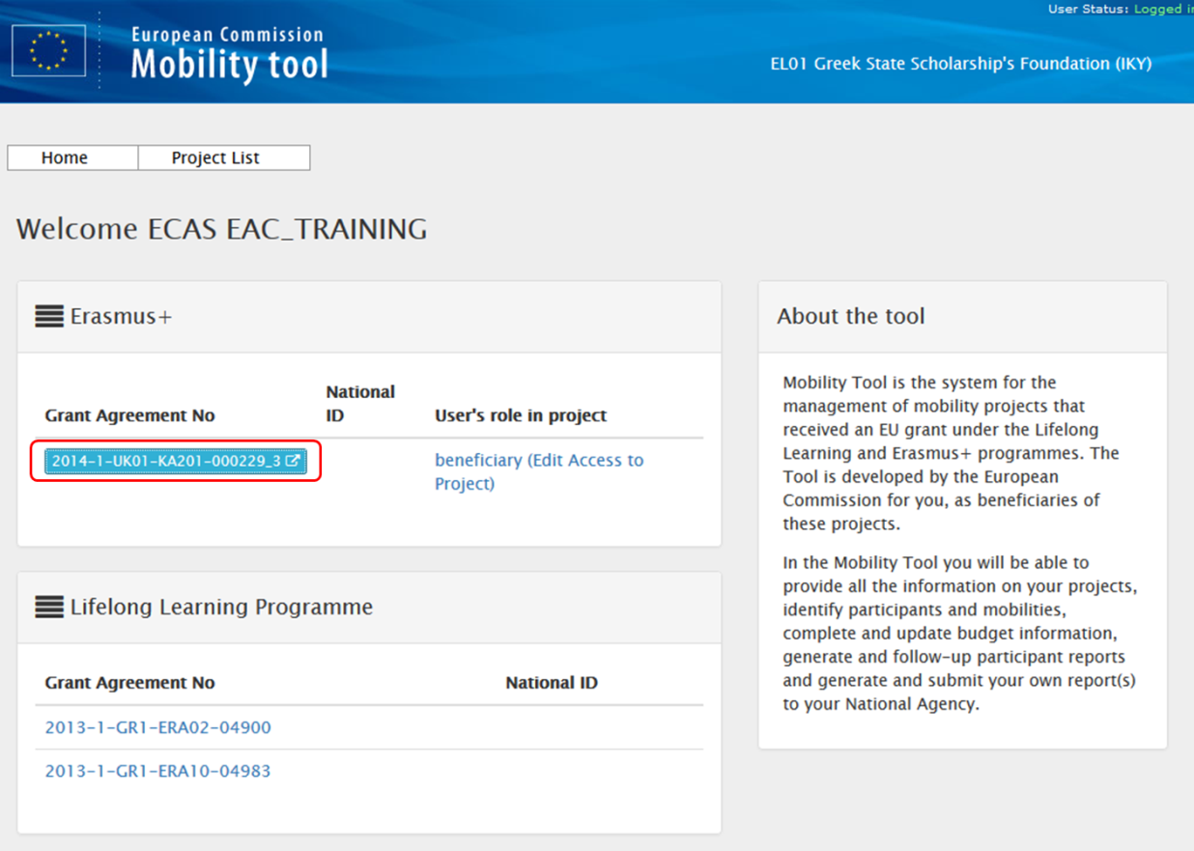

- Click the menu item "Exceptional Costs".
Click on the menu item Exceptional Costs.
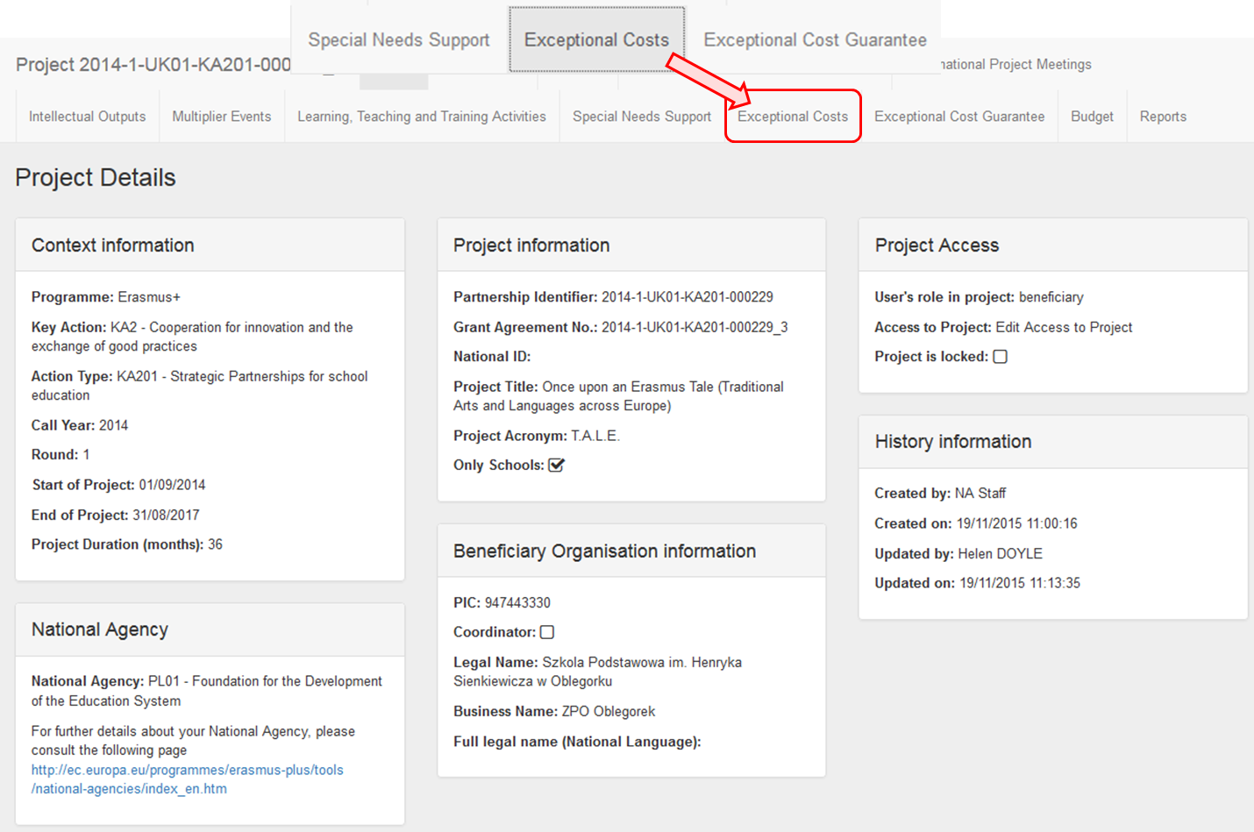

The Exceptional Costs window appears.
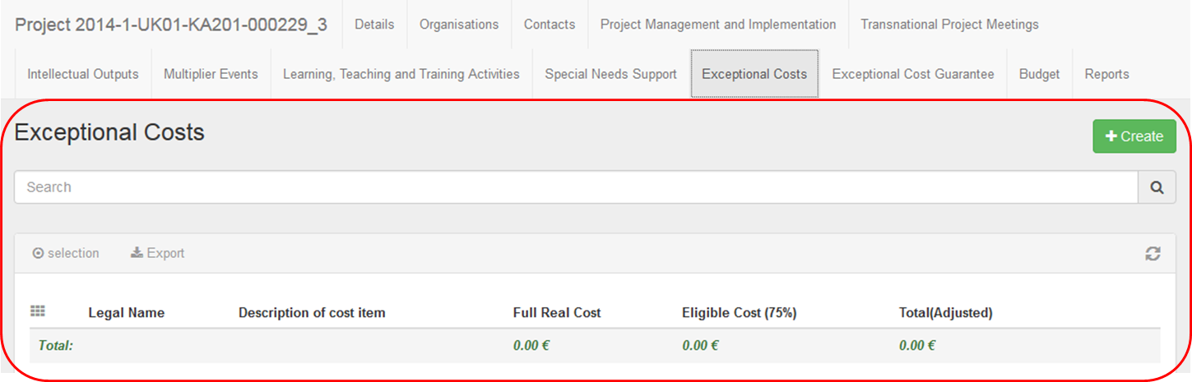

- Click the "+Create" button.
In order to create a new details line, click on the +Create button.
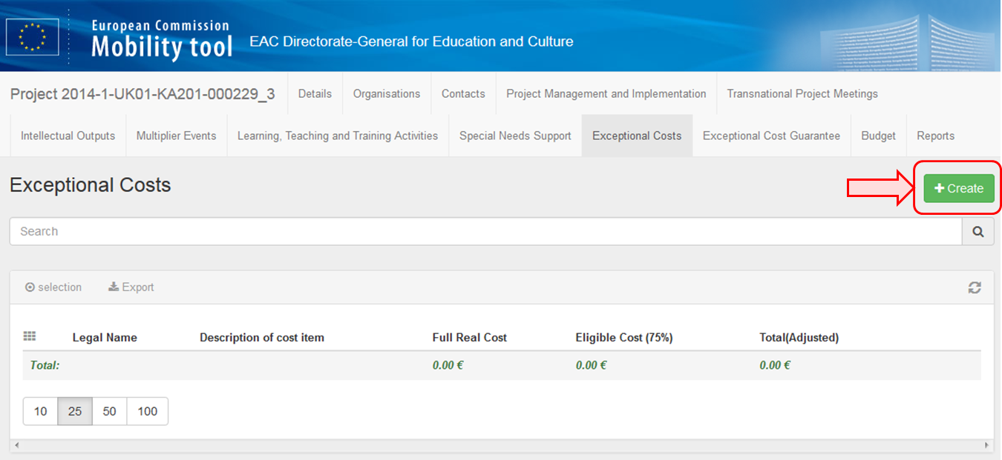

- Fill in the details.
Fill in the details (blank fields) as applicable.
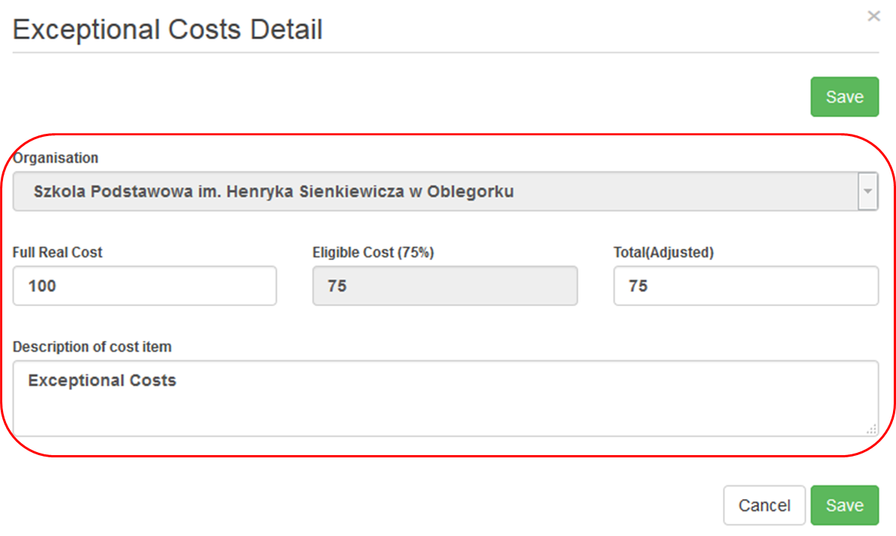

- Click on "Save".
To save the data, click the Save button.
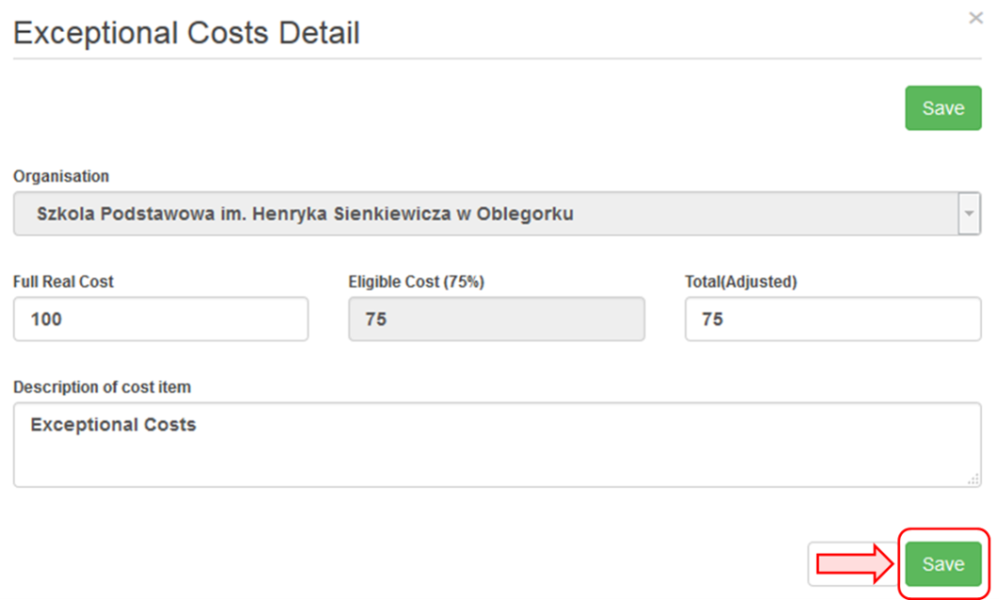
After saving, the details line will now appear in the list.
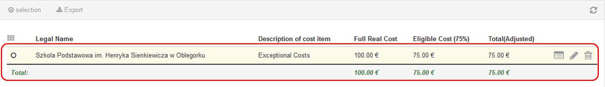

- Add a comment
Add a comment in relation to all exceptional costs on the budget screen.
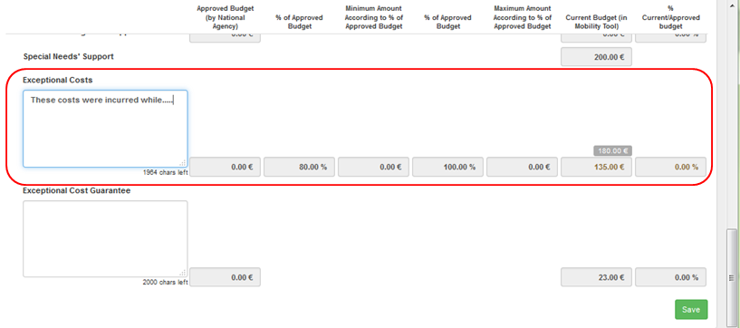

MT+ KA2 Budget
- Approved Budget (by National Agency) and Current Budget (in Mobility Tool).
- Allowed budget transfers between budget items.
- Maximum and minimum percentage allowed for the transfer.
- Budget for Learning, Teaching and Training Activities.
- Budget for Exceptional Costs and Exceptional Cost Guarantee.
- Reduction of EU Grant.

Approved Budget (by National Agency) and Current Budget (in Mobility Tool).

Explanation and illustration
The budget summary screen provides an overview of the approved budget as entered into EPlusLink. This can be seen in the column Approved Budget (by National Agency).
The column Current Budget (in Mobility Tool) reflects the total for each activity and budget item as entered under each tab of the Mobility Tool:
- Project management and implementation
- Transnational Project Meetings
- Intellectual Outputs
- Multiplier Events
- Learning, Teaching and Training Activities
- Special Needs' Support
- Exceptional Costs
- Exceptional Cost Guarantee
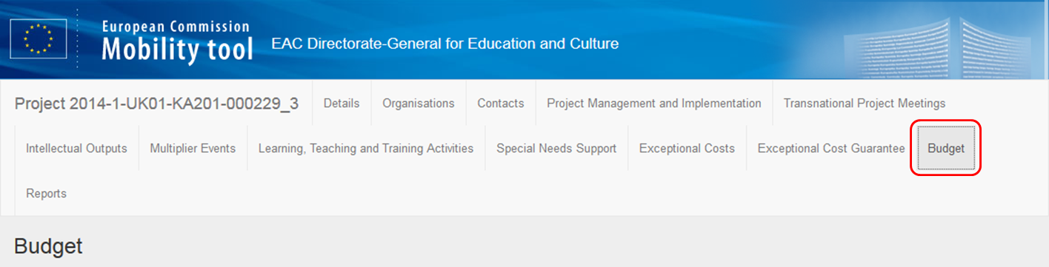
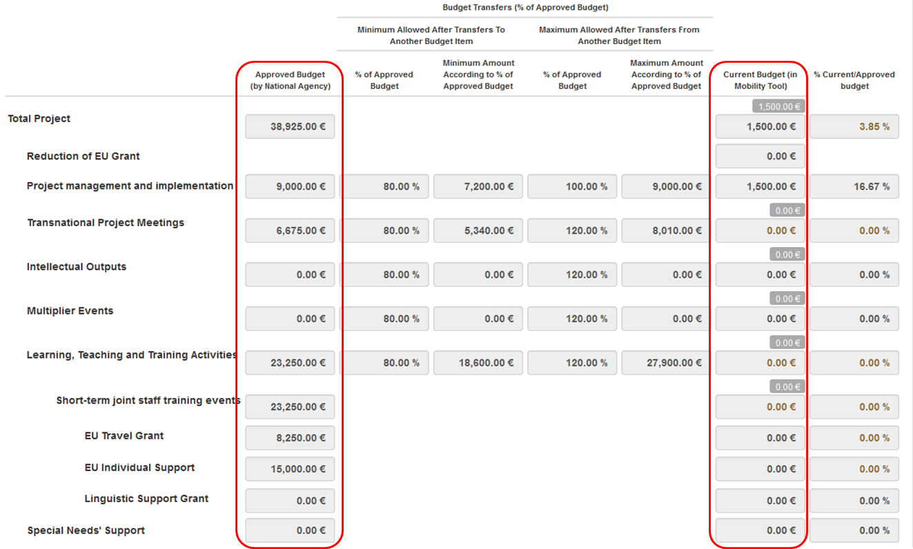
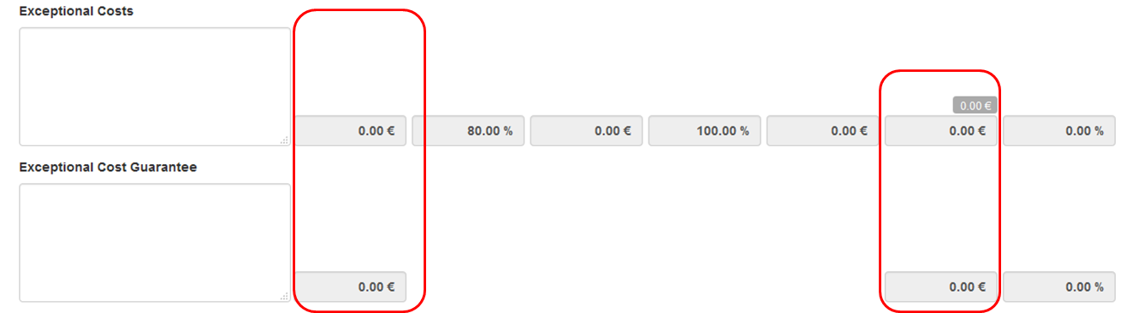

Allowed budget transfers between budget items.

Explanation and illustration
Transfer between budget items is allowed but only as indicated in the table below:
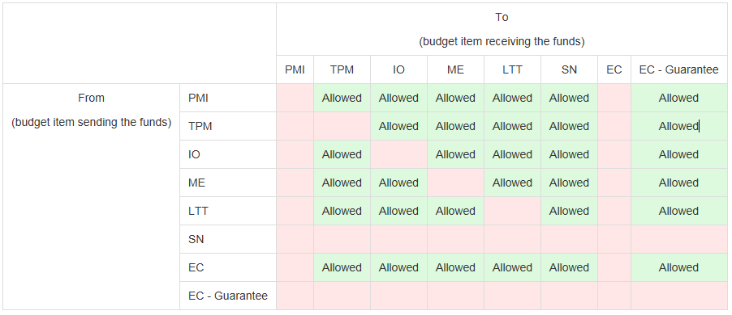

Maximum and minimum percentage allowed for the transfer.

Explanation and illustration
Where transfer is allowed from or to a budget item, the maximum and minimum percentage allowed is displayed. Also, both the minimum value and the maximum value are automatically calculated and displayed here.
If these limits are exceeded the cell will display in orange and the amount should be adjusted under the appropriate tab for that budget item.
If the amount is different than the approved budget but within the allowed limits it will be displayed in red. The highlight in red is only for information and will not block any functionality.
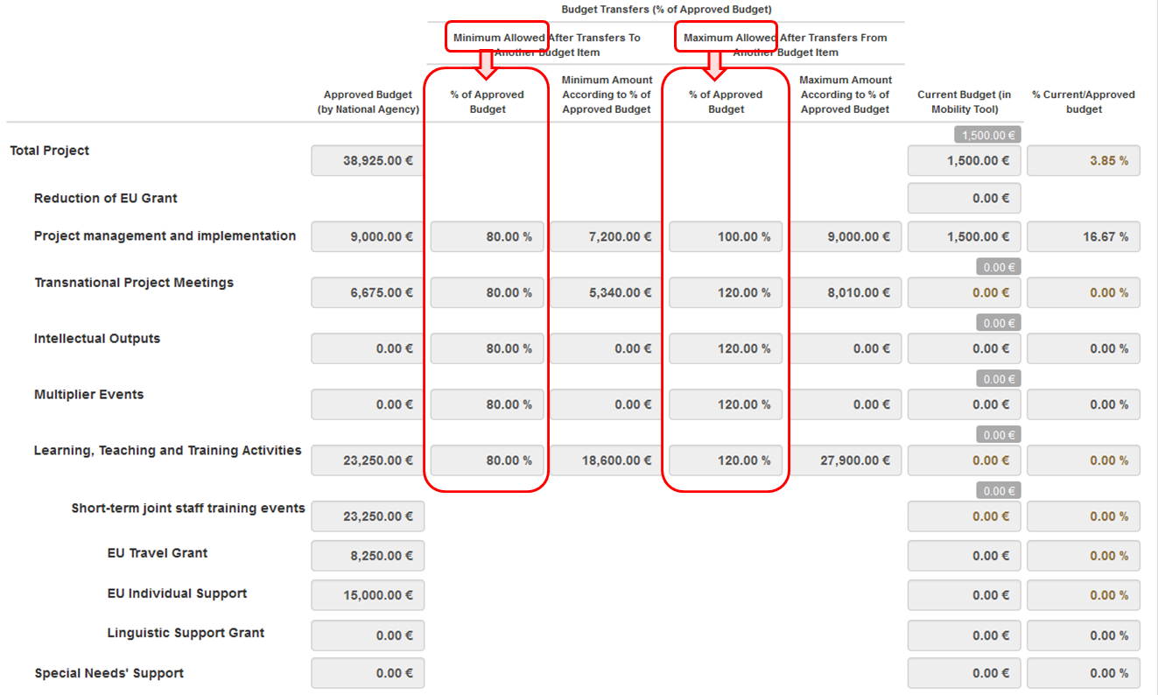
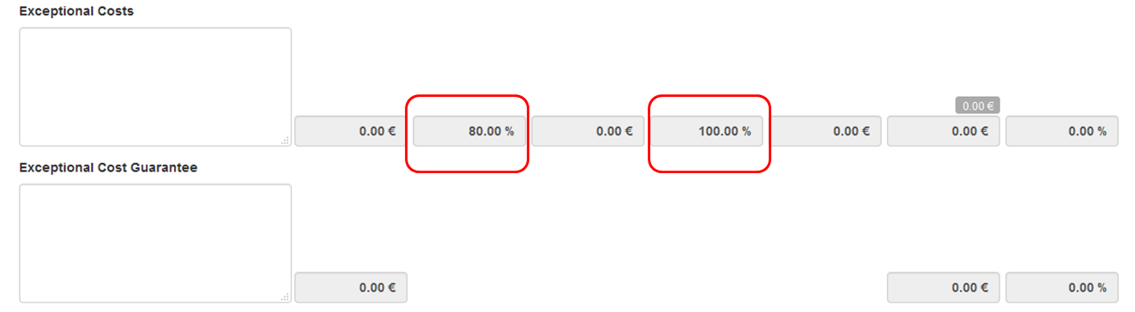

Budget for Learning, Teaching and Training Activities.

Explanation and illustration
Learning Teaching and Training Activities budget item is further divided into the activity types.
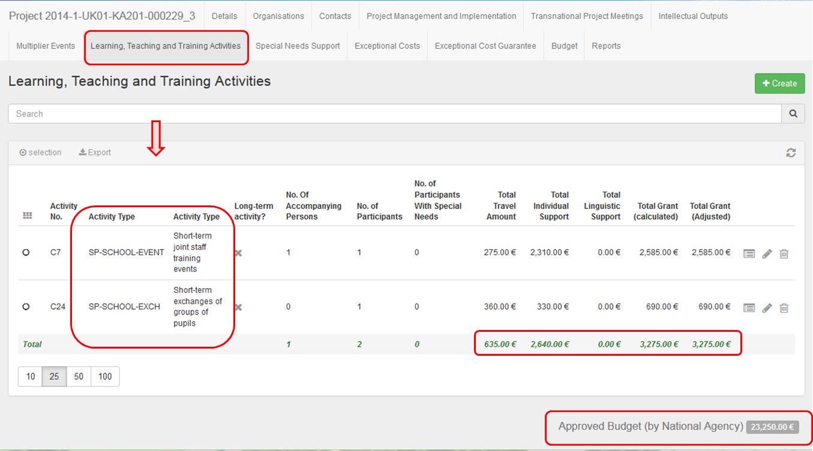
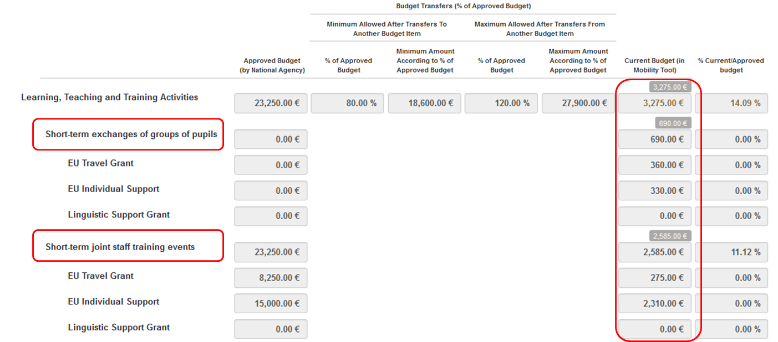

Budget for Exceptional Costs and Exceptional Cost Guarantee.

Explanation and illustration
The Exceptional Costs and Exceptional Cost Guarantee both have comments fields. A comment should be entered and saved, if either items have costs entered.
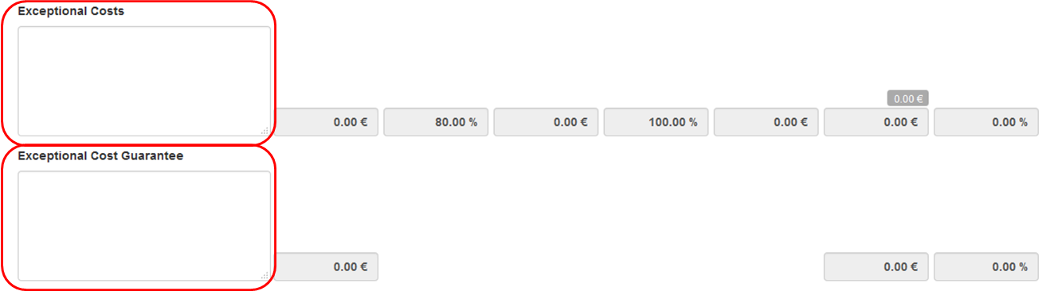

Reduction of EU Grant.

Explanation and illustration
After the National Agency has processed the final report the total amount by which the current budget can be reduced may be entered if necessary by the NA into the field Reduction of EU Grant.
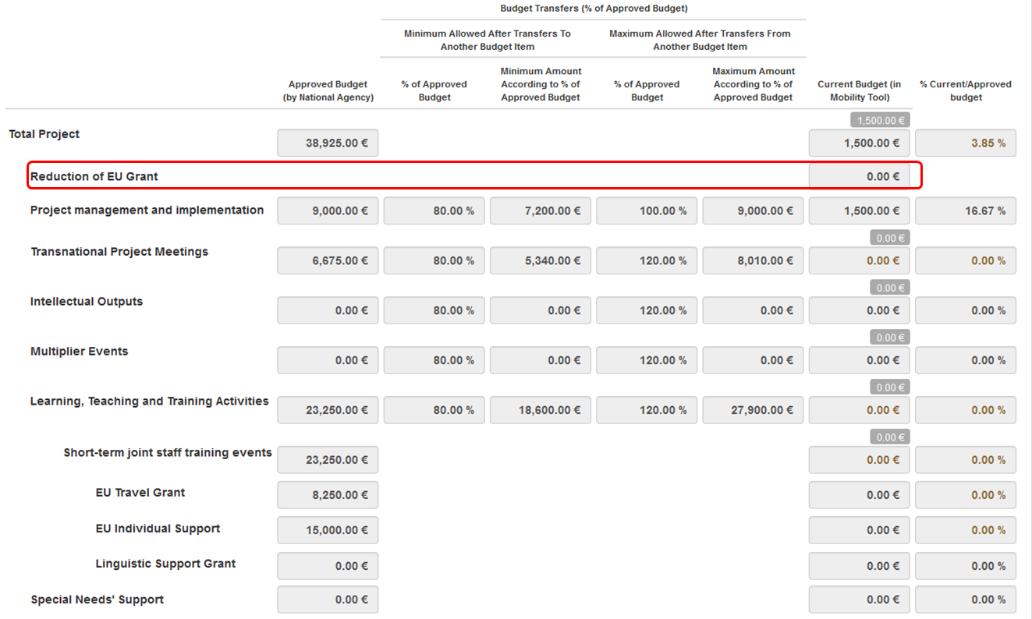

How to complete and submit the beneficiary report
This video file cannot be printed but was made available to the National Agencies last year to be distributed via their own channels.
Length of video | Version of Tool | Comments
5min 35sec | MT+1.6.2 and EPlusLink 2.3.1 | This overview while created for older versions of MT+ and EPlusLink is still relevant for most of the current functionality.  New following functionality not shown in this video.  - The Project summary, Context and Budget sections are already filled in.  - For KA107, Context, Summary of Beneficiary and Partner Organisations and Participant Feedback on Erasmus Charter Provisions and General Issues are already filled in.  - Maximum number of attachments: 10 (instead of 5).  - Maximum size for the attachments: 10 MB (instead of 5 MB).

Video
URL: How to complete and submit the beneficiary report
QR code:


